Lesson Overview: Data Science Application Domains
In this lesson, "Data Science Application Domains," you'll embark on a journey to explore the vast and impactful realms where data science plays a pivotal role. This engaging module delves into various activities that shed light on the diverse applications of data science in our world today. You'll uncover how data science drives innovation and transformation across different sectors, from revolutionizing industries to saving lives.
Dive into this lesson to discover the real-world applications that define the dynamic landscape of data science.
Asset name and type | Description
“How Should Companies Get Started in Data Science?” video | Gain insights into how organizations can embark on their data science journey effectively.
“Old problems with New Data Science Solutions” video | Discover how data science offers innovative solutions to age-old and real-world problems.
“Applications of Data Science” video | Explore the wide-ranging applications of data science across various industries and sectors.
“How Data Science is saving lives” video | In this video, you will learn about the life-saving potential of data science in healthcare and beyond.
“The Final Deliverable” reading | Dive into the details of what constitutes the final deliverable in data science projects.
Practice quiz | Test your understanding of the previous reading.
“Lesson Summary” video | Recap the essential takeaways from this module with a lesson summary.
Practice quiz | Take a practice quiz to evaluate how well you’ve understood the material presented in this lesson.
Glossary | Use this glossary of terms to review the terminology presented in this lesson.

Uzr, to‘g‘ri aytasiz! Oxirgi yuborgan xabaringizda "Asset name and type" va "Description" ustunlaridan iborat jadval bor edi. Men uni umumiy mazmun sifatida tushuntirib ketibman.
Mana, o‘sha jadvalning to‘liq o‘zbekcha tarjimasi:

Dars materiallari jadvali (Asset Name and Description)
Material nomi va turi (Asset name and type) | Tavsifi (Description)
“How Should Companies Get Started in Data Science?” video | Tashkilotlar o‘zlarining Data Science (Ma'lumotlar fani) bo‘yicha sayohatini qanday qilib samarali boshlashlari mumkinligi haqida tushunchaga ega bo‘ling.
“Old problems with New Data Science Solutions” video | Data Science qanday qilib ko‘hna va real hayotdagi muammolarga innovatsion (yangi) yechimlar taklif qilishini kashf eting.
“Applications of Data Science” video | Data Sciencening turli sanoat va sohalardagi keng ko‘lamli qo‘llanilishini o‘rganing.
“How Data Science is saving lives” video | Ushbu videoda siz Data Sciencening sog‘liqni saqlash va undan tashqari sohalarda inson hayotini saqlab qolish salohiyati haqida bilib olasiz.
“The Final Deliverable” reading (o'qish uchun) | Data Science loyihalarida "Yakuniy natija" (mahsulot) nimalardan iborat ekanligi haqidagi tafsilotlarga sho‘ng‘ing.
Practice quiz | Oldingi o‘qish materialini qanchalik tushunganingizni sinab ko‘ring.
“Lesson Summary” video | Ushbu moduldan olingan asosiy xulosalarni qisqacha takrorlang.
Practice quiz | Ushbu darsda taqdim etilgan materiallarni qanchalik yaxshi tushunganingizni baholash uchun mashq testini yeching.
Glossary | Ushbu darsda taqdim etilgan atamalarni takrorlash uchun ushbu lug‘atdan foydalaning.
Graded quiz | Baholanadigan testni ishlash orqali ushbu darsdagi bilimlaringizni sinovdan o‘tkazing.

[MUSIC] At the end of the day, for businesses, they know one thing, that if they are unable to measure something, they are unable to improve it. And if they are unable to measure their costs, they are unable to reduce them. If they're unable to measure their profits, they are unable to increase them. So the first thing a company has to do is to start recording information, start capturing data, data about costs. And the differentiate it by labor costs and material cost, the cost to how much it cost to sell one product and the total cost. And then you look at the revenue, where's your revenue coming from? Is 80% of your revenue coming from 20% of your customers?
Or is it the other way around? So first thing first, start capturing data. Once you have data, then you can apply algorithms and analytics to it. So the first thing to do would be to capture data. If you're not capturing it, start capturing it. If you're capturing it, archive it. Do not overwrite on your old data thinking you don't need it anymore.
Data never gets old. Data is always relevant, even if it's 100 years old, 200 years old. It is relevant to you and and your firm and your success. So keep data, capture it, archive it, make sure nothing goes to waste. Make sure there's a consistency. So someone 20 years later trying to understand, that data should be able to do so, so have proper documentation. Do it now.
Put the best practices for data archiving in place the moment you start a business. And if you're already in business and you haven't done it, do it now. Start measuring things. Too many companies haven't measured things properly for a decade and, then they decide, they want data science. Data science inside a company is only going to be as valuable as the data collected. Garbage in, garbage out is a rule in any sort of analysis. If something is not measured, it's very difficult to improve it or to change it.
So the very first step is measurement. If companies have existing data, then they should start looking at it and cleaning it. If they don't have existing data, then they need to start collecting it. I think to look for a team who love to work as a data scientist. The first stop is to have employees, that they are interested on data science. Because if you don't have interest in your company, you will not have engagement. Companies should remember, that it's key to have a team.
So it's not one data scientist, but a team of them, that each of them have strengths in different areas of data science. [MUSIC]

Ushbu videotranskript kompaniyalar Data Science (Ma'lumotlar fani)ni qanday boshlashi kerakligi haqidagi eng muhim qoidani tushuntiradi.

1. To‘liq Tarjima: Kompaniyalar nimadan boshlashi kerak?
Kun oxirida bizneslar bitta oltin qoidani bilishadi: Agar ular biror narsani o'lchay olmasalar, uni yaxshilay olmaydilar.
Agar ular xarajatlarini o'lchay olmasalar, ularni kamaytira olmaydilar. Agar foydani o'lchay olmasalar, uni ko'paytira olmaydilar.
Shuning uchun kompaniya qilishi kerak bo'lgan birinchi ish — ma'lumotlarni yozib olishni va yig'ishni boshlashdir. Xarajatlar haqida ma'lumot: ishchi kuchi xarajatlari, xomashyo xarajatlari, bitta mahsulotni sotish qanchaga tushishi va umumiy xarajatlar.
Keyin daromadga qaraysiz: Pulingiz qayerdan kelyapti? Daromadingizning 80 foizi mijozlaringizning 20 foizidan kelyaptimi? Yoki teskarisimi?
Demak, birinchi navbatda: Ma'lumot yig'ishni boshlang. Faqat ma'lumot (data) bor bo'lgandan keyingina, siz unga algoritmlar va analitikani qo'llashingiz mumkin.
Agar ma'lumot yig'mayotgan bo'lsangiz, hoziroq boshlang. Agar yig'ayotgan bo'lsangiz, uni arxivlang. "Bu menga kerak emas" deb eski ma'lumotlarning ustiga yozib yubormang.
Ma'lumot hech qachon eskirmaydi. U 100 yoshda bo'lsa ham, 200 yoshda bo'lsa ham sizning muvaffaqiyatingiz uchun muhim. Ma'lumotni saqlang, arxivlang va hech narsa isrof bo'lmasligiga ishonch hosil qiling. Hujjatlashtirishni shunday qilingki, 20 yildan keyin kelgan odam ham uni tushuna olsin.
Juda ko'p kompaniyalar o'n yillar davomida narsalarni to'g'ri o'lchamasdan turib, birdaniga "Bizga Data Science kerak" deb qolishadi. Kompaniya ichidagi Data Science faqat yig'ilgan ma'lumot sifati darajasida qadrli bo'la oladi.
Har qanday tahlilda bitta qoida bor: "Chiqindi kirdi — Chiqindi chiqdi" (Garbage in, Garbage out).
Shuningdek, Data Sciencega qiziqadigan xodimlarni topish kerak. Chunki kompaniyada qiziqish bo'lmasa, natija bo'lmaydi. Va unutmang, bu bir kishining ishi emas. Bu turli sohalarda kuchli bo'lgan mutaxassislardan iborat jamoaviy ishdir.

2. Sodda tushuntirish (Hayotiy misol)
Keling, buni oddiy "Oshxona daftari" misolida ko'ramiz.

A. "O'lchamasangiz — boshqara olmaysiz"
Tasavvur qiling, siz somsa pishirib sotasiz. Kechqurun hamyoningizda pul bor, lekin siz foydadamisiz yoki zarardamisiz? Buni bilmaysiz.
- Agar siz har kuni daftarga: "Un uchun 50 ming, go'sht uchun 100 ming ketdi, 200 ta somsa sotdim" deb yozib bormasangiz, biznesingizni rivojlantira olmaysiz. Data Science mana shu **"Daftar tutish"**dan boshlanadi.

B. Arxivlash nima uchun kerak?
Siz daftarni to'lgach, tashlab yubormang.
- Nega? Chunki 3 yildan keyin daftarni ochib qaraysiz: "Qiziq, o'tgan yili Ramazon oyida savdo qanday bo'lgan ekan?"
- Eski ma'lumot sizga kelajakni rejalashtirishga yordam beradi. "O'tgan yili qishda go'sht qimmatlagan ekan, bu yil g'amlab qo'yay", deysiz.

C. "Chiqindi kirdi — Chiqindi chiqdi" (Garbage in, Garbage out)
Bu juda mashhur ibora.
- Agar siz daftarga un narxini 5000 so'm o'rniga adashib 500 so'm deb yozib qo'ysangiz (Chiqindi ma'lumot kiritdingiz), hisoblagich sizga "Oho, siz millioner bo'lib ketibsiz!" deb xato natija chiqaradi (Chiqindi natija chiqdi).
- Sun'iy intellekt ham xuddi shunday: agar unga noto'g'ri ma'lumot bersangiz, u sizga noto'g'ri maslahat beradi.

D. Jamoa kerak
Siz ham somsa yopib, ham kassada o'tirib, ham hisob-kitob qila olmaysiz.
- Data Science'da ham shunday: bir kishi kod yozadi, boshqasi biznesni tushunadi, uchinchisi ma'lumotni tozalaydi. Bu jamoaviy sport turi.

3. Asosiy terminlar
- Measurement (O'lchov): Biznesdagi har bir harakatni (xarajat, daromad) raqamlashtirish.
- Archiving (Arxivlash): Ma'lumotlarni o'chirib yubormasdan, kelajak uchun saqlab qo'yish.
- Garbage in, Garbage out: Sifatsiz ma'lumotdan sifatsiz natija chiqadi degan qoida.
- Teamwork (Jamoaviy ish): Data Science bir kishining ishi emasligi.
Xulosa:
Data Science qimmat kompyuterlardan boshlanmaydi. U oddiygina qilib bugungi ishlarni qog'ozga (yoki Excelga) to'g'ri yozib borishdan boshlanadi.

​

Interactive Transcript - Enable basic transcript mode by pressing the escape key
You may navigate through the transcript using tab. To save a note for a section of text press CTRL + S. To expand your selection you may use CTRL + arrow key. You may contract your selection using shift + CTRL + arrow key. For screen readers that are incompatible with using arrow keys for shortcuts, you can replace them with the H J K L keys. Some screen readers may require using CTRL in conjunction with the alt key
[Music] Organizations can leverage the almost unlimited amount of data now available to them in a growing number of ways. However, all organizations ultimately use data science for the same reason—to discover optimum solutions to existing problems. Let’s take a look at three examples of data science providing innovative solutions for old problems. In transport, Uber collects real-time user data to discover how many drivers are available, if more are needed, and if they should allow a surge charge to attract more drivers. Uber uses data to put the right number of drivers in the right place, at the right time, for a cost the rider is willing to pay. In a different transport related data science effort, the Toronto Transportation Commission has made great strides in solving an old problem with traffic flows, restructuring those flows in and around the city. Using data science tools and analysis, they have: Gathered data to better understand streetcar operations, and identify areas for interventions; Analyzed customer complaints data; Used probe data to better understand traffic performance on main routes and created a team to better capitalize on big data for both planning operations and evaluation.
By focusing on peak hour clearances and identifying the most congested routes, monthly hours lost for commuters due to traffic congestion dropped from 4.75 hrs. in 2010 to 3 hrs. in mid-2014. In facing issues in our environment, data science can also play a proactive role. Freshwater lakes supply a variety of human and ecological needs, such as providing drinking water and producing food. But lakes across the world are threatened by increasing incidences of harmful cyanobacterial blooms. There are many projects and studies to solve this long-existing dilemma. In the US, a team of scientists from research centers stretching from Maine to South Carolina is developing and deploying high-tech tools to explore cyanobacteria in lakes across the east coast. The team is using robotic boats, buoys, and camera-equipped drones to measure physical, chemical, and biological data in lakes where cyanobacteria are detected, collecting large volumes of data related to the lakes and the development of the harmful blooms.
The project is also building new algorithmic models to assess the findings. The information collected will lead to better predictions of when and where cyanobacterial blooms take place, enabling proactive approaches to protect public health in recreational lakes and in those that supply drinking water. Such interdisciplinary training prepares the next generation of scientists to address societal issues with the proper modernized data science tools. It takes gathering a lot of data, cleaning and preparing it, and then analyzing it to gain the insight needed to develop better solutions for today's enterprises. How do you get a better solution that is efficient? You must: Identify the problem and establish a clear understanding of it; Gather the data for analysis; Identify the right tools to use; And develop a data strategy. Case studies are also helpful in customizing a potential solution.
Once these conditions exist and available data is extracted, you can develop a machine learning model. It will take time for an organization to refine best practices for data strategy using data science, but the benefits are worth it. [Music]

Ushbu videotranskript "Eski muammolarga Data Science yordamida yangi yechimlar" haqida. Unda taksi xizmati, shahar tirbandligi va ekologiya misolida ma'lumotlar fanining kuchi ko‘rsatib berilgan.
Keling, odatdagi tartibimizda davom etamiz.

1. To‘liq Tarjima: Eski muammolar, Yangi yechimlar
Tashkilotlar hozirda mavjud bo‘lgan deyarli cheksiz miqdordagi ma'lumotlardan foydalanishning ko‘plab usullarini qo‘llamoqdalar. Biroq, barcha tashkilotlar oxir-oqibat Data Sciencedan bitta maqsadda foydalanadilar — mavjud muammolarga eng maqbul (optimal) yechimlarni topish.
Keling, Data Science eski muammolarga innovatsion yechim bergan uchta misolni ko‘rib chiqamiz.
1. Transport (Uber misolida):
Uber qancha haydovchi mavjudligini, yana qo‘shimcha haydovchi kerakmi yoki yo‘qligini va ko‘proq haydovchilarni jalb qilish uchun narxni oshirish (surge charge) kerakligini aniqlash uchun real vaqt rejimida foydalanuvchi ma'lumotlarini yig‘adi.
Uber ma'lumotlardan foydalanib, to‘g‘ri miqdordagi haydovchilarni, to‘g‘ri vaqtda, to‘g‘ri joyga va yo‘lovchi to‘lashga rozi bo‘lgan narxda joylashtiradi.
2. Shahar tirbandligi (Toronto transport komissiyasi):
Toronto transport komissiyasi shahardagi va uning atrofidagi transport oqimini qayta tuzish orqali tirbandlik bilan bog‘liq eski muammoni hal qilishda katta qadam tashladi. Ular Data Science vositalari va tahlillaridan foydalanib:
- Tramvaylar harakatini yaxshiroq tushunish uchun ma'lumot yig‘ishdi;
- Mijozlarning shikoyatlarini tahlil qilishdi;
- Asosiy yo‘llardagi holatni tushunish uchun sensor (probe) ma'lumotlaridan foydalanishdi.
Natijada, eng tirband sohalarga e'tibor qaratish orqali, yo‘lovchilarning tirbandlikda yo‘qotgan vaqti 2010-yildagi 4.75 soatdan 2014-yilda 3 soatga tushdi.
3. Atrof-muhit (Ko‘llarni qutqarish):
Chuchuk suv ko‘llari ichimlik suvi va oziq-ovqat manbai hisoblanadi. Lekin dunyo bo‘ylab ko‘llar zararli sianobakteriyalar (suv o‘tlari) ko‘payishi xavfi ostida. AQShda olimlar guruhi robot-qayiqlar, buyoklar va kamerali dronlardan foydalanib, ko‘llarning fizik, kimyoviy va biologik ma'lumotlarini yig‘moqdalar.
Bu ma'lumotlar asosida yangi algoritmlar tuzilib, zararli bakteriyalar qachon va qayerda paydo bo‘lishini oldindan bashorat qilish imkonini beradi. Bu esa aholi salomatligini himoya qiladi.
Yechim topish jarayoni:
Samarali yechim topish uchun siz:
- Muammoni aniqlashingiz va tushunishingiz;
- Tahlil uchun ma'lumot yig‘ishingiz;
- To‘g‘ri vositalarni tanlashingiz;
- Va ma'lumotlar strategiyasini ishlab chiqishingiz kerak.

2. Sodda tushuntirish (Hayotiy misollar bilan)
Bu videoda Data Science shunchaki kompyuter o‘yini emas, balki hayotiy muammolarni hal qiluvchi "Aqlli Boshqaruvchi" ekanligi ko‘rsatilgan.

A. Uber: "Bozordagi tarozi"
Tasavvur qiling, bozorda pomidor kam, xaridor esa ko‘p. Narx oshadi, shunda dehqonlar ko‘proq pomidor olib kelishga qiziqadi.
- Uber ham xuddi shunday. Yomg‘ir yog‘sa (talab oshsa), u avtomatik ravishda narxni ko‘taradi. Bu haydovchilarga: "Hey, hozir chiqib ishlasang, ko‘p pul topasan!" degan signaldir. Natijada taksi ko‘payadi va siz yomg‘irda qolib ketmaysiz. Buni odam emas, algoritm boshqaradi.

B. Tirbandlik: "Aqlli Svetofor"
Toronto shahri misolida: Ilgari yo‘llarda tirbandlik bo‘lsa, shahar ma'muriyati "Yo‘l torlik qilyapti" deb o‘ylardi.
- Data Science esa aniqladi: Muammo yo‘lda emas, balki tramvaylarning noto‘g‘ri vaqtda yurishida ekan. Ular jadvallarni o‘zgartirishdi va odamlarning har oy tirbandlikda o‘tkazadigan deyarli 2 soat vaqtini tejab qolishdi.

C. Ko‘llar: "Tabiat Shifokori"
Ko‘llar ba'zan "kasal" bo‘ladi (suv yashil bo‘lib, zaharlanib qoladi). Ilgari odamlar suv zaharli bo‘lib qolganini baliqlar o‘lgandan keyin bilishardi.
- Hozir olimlar dronlar va robot-qayiqlar yordamida suvning "qon bosimini" (kimyoviy tarkibini) har kuni o‘lchab turishadi. Agar xavf tug‘ilsa, kompyuter: "Diqqat! 2 kundan keyin bu ko‘lda cho‘milish xavfli!" deb oldindan xabar beradi.

D. Yechim retsepti
Muvaffaqiyatli Data Science loyihasi xuddi palov damlashga o‘xshaydi:
- Muammo: Qorin ochdi (Maqsadni aniqlash).
- Ma'lumot: Guruch, sabzi, go‘sht bormi? (Ma'lumot yig‘ish).
- Vositalar: Qozon va o‘choq (To‘g‘ri vositani tanlash).
- Strategiya: Qaysi biri avval qovuriladi? (Reja tuzish).
- Model: Damlash (Algoritm).

3. Asosiy terminlar
- Leverage (Foydalanish/Ishlatish): Bor imkoniyatdan (ma'lumotdan) maksimal foyda olish.
- Surge Charge (Oshirilgan narx): Talab yuqori bo‘lganda narxning vaqtincha ko‘tarilishi (Uber/Yandex Go).
- Probe Data (Sensor ma'lumotlari): Mashinalar yoki telefonlardan olingan GPS harakat ma'lumotlari.
- Cyanobacteria (Sianobakteriya): Suvni ifloslantiruvchi va zaharlovchi ko‘k-yashil suvo‘tlar.
- Proactive (Proaktiv/Oldindan harakat qilish): Muammo sodir bo‘lishini kutmasdan, uni oldindan bartaraf etish.
Xulosa:
Siz o‘rganganingizdek, Data Science faqat biznes uchun emas. U sizning taksingiz tezroq kelishiga, ishga kech qolmasligingizga va toza suv ichishingizga yordam beradi.

[MUSIC] Data science and big data are making an undeniable impact on businesses, changing day to day operations, financial analytics, and especially interactions with customers. It's clear that businesses can gain enormous value from the insights data science can provide, but sometimes it's hard to see exactly how. So let's look at some examples. In this era of big data, almost everyone generates masses of data every day, often without being aware of it. This digital trace reveals the patterns of our online lives. If you have ever searched for or bought a product on a site like Amazon, you will notice that it starts making recommendations related to your search. This type of system, known as a recommendation engine, is a common application of data science.
Companies like Amazon, Netflix, and Spotify use algorithms to make specific recommendations derived from customer preferences and historical behavior. Personal assistants like Siri on Apple devices use data science to devise answers to the infinite number of questions end users may ask. Google watches your every move in the world, your online shopping habits, and your social media. Then it analyzes that data to create recommendations for restaurants, bars, shops, and other attractions based on the data collected from your device and your current location. Wearable devices like Fitbits, Apple watches, and Android watches add information about your activity levels, sleep patterns, and heart rate to the data you generate. Now that we know how consumers generate data, let's take a look at how data science is impacting business. In 2011, McKinsey and Company said that data science was going to become the key basis of competition, supporting new waves of productivity, growth, and innovation.
In 2013, UPS announced that it was using data from customers, drivers and vehicles in a new route guidance system aimed to save time, money, and fuel. Initiatives like this support the statement that data science will fundamentally change the way businesses compete and operate. How does a firm gain a competitive advantage? Lets take Netflix as an example. Netflix collects and analyzes massive amounts of data from millions of users, including which shows people are watching at what time of day when people pause, rewind, and fast forward, and which shows directors and actors they search for, Netflix can be confident that a show will be a hit before filming even begins, by analyzing users preference for certain directors and acting talent, and discovering which combinations people enjoy. Add this to the success of earlier versions of a show and you have a hit. For example, Netflix knew many of its users had streamed the work of David Fincher.
They also knew that films featuring Robin Wright had always done well, and that the british version of House of Cards was very successful. Netflix knew that significant numbers of people who liked Fincher also liked Wright. All this information combined to suggest that buying the series would be a good investment for the company. They were right. It was a huge hit. Thanks to data science. Netflix knows what people want before they do.

Ushbu videotranskript Data Science biznesda, xususan mijozlar bilan ishlashda qanday inqilob qilayotgani haqida. Unda asosan Netflix va Amazon kabi kompaniyalar bizning har bir harakatimizni qanday kuzatishi va shunga qarab pul topishi tushuntirilgan.

1. To‘liq Tarjima: Data Science biznesni qanday o‘zgartirmoqda?
Data Science va Big Data (Katta ma'lumotlar) biznesga, kundalik operatsiyalarga, moliyaviy tahlillarga va ayniqsa mijozlar bilan munosabatlarga shubhasiz ta'sir ko‘rsatmoqda. Bizneslar Data Science beradigan tushunchalardan ulkan foyda olishi mumkinligi aniq, ammo ba'zan bu aynan qanday sodir bo‘lishini ko‘rish qiyin. Keling, misollarni ko‘rib chiqamiz.
Big Data davrida deyarli har bir kishi har kuni bilmasdan turib katta hajmdagi ma'lumotlarni yaratadi. Bu "Raqamli iz" (Digital trace) bizning onlayn hayotimizdagi naqshlarni ochib beradi.
Agar siz Amazon kabi saytlarda biror mahsulot qidirgan yoki sotib olgan bo‘lsangiz, u darhol sizning qidiringizga aloqador boshqa narsalarni tavsiya qilishni boshlaganini sezasiz. Tavsiya dvigateli (Recommendation engine) deb ataladigan ushbu tizim Data Sciencening eng keng tarqalgan qo‘llanilishidir.
Amazon, Netflix va Spotify kabi kompaniyalar mijozlarning xohish-istaklari va oldingi harakatlaridan kelib chiqib, aniq tavsiyalar berish uchun algoritmlardan foydalanadilar. Apple’dagi Siri kabi shaxsiy yordamchilar foydalanuvchilar berishi mumkin bo‘lgan cheksiz savollarga javob topish uchun Data Sciencedan foydalanadi. Google sizning har bir qadamingizni, onlayn xaridlaringizni va ijtimoiy tarmoqlaringizni kuzatadi. Keyin u sizning joylashuvingiz va ma'lumotlaringizga asoslanib, restoranlar, barlar va do‘konlarni tavsiya qiladi. Fitbit va Apple Watch kabi taqiladigan qurilmalar esa yurak urishi va uyqu rejimi haqidagi ma'lumotlarni qo‘shadi.
Biznesdagi raqobat:
2011-yilda McKinsey kompaniyasi Data Science raqobatning asosiy poydevori bo‘lishini aytgan edi. 2013-yilda UPS (pochta xizmati) mijozlar, haydovchilar va mashinalardan olingan ma'lumotlar asosida yangi yo‘nalish tizimini ishga tushirdi. Bu vaqt, pul va yoqilg‘ini tejashga qaratilgan edi.
Netflix muvaffaqiyati siri ("House of Cards" misolida):
Qanday qilib kompaniya raqobatda ustunlikka erishadi? Netflix millionlab foydalanuvchilarning ma'lumotlarini tahlil qiladi: ular qaysi ko‘rsatuvni ko‘ryapti, qachon pauza qilyapti, qachon orqaga qaytaryapti va qaysi aktyorlarni qidiryapti.
Netflix biror filmni suratga olishdan oldin uning xit bo‘lishiga ishonchi komil bo‘ladi.
Masalan, Netflix quyidagilarni bilar edi:
- Ko‘pchilik rejissyor David Fincherning ishlarini yaxshi ko‘radi.
- Aktrisa Robin Wright qatnashgan filmlar doim yaxshi ketgan.
- Britaniyaning "House of Cards" seriali juda mashhur bo‘lgan.
Algoritm shuni ko‘rsatdiki: Fincher va Wright muxlislari Britaniya serialini ham yoqtirishadi. Netflix bu uchta elementni birlashtirib, "House of Cards" (Amerikacha versiya)ni suratga oldi va u olamshumul muvaffaqiyatga erishdi. Ular buni oldindan bilishardi.

2. Sodda tushuntirish (Hayotiy misollar)
Bu videoda bizni "kuzatuvchi" va bizga "yoqadigan narsani topib beruvchi" texnologiyalar haqida gap ketadi.

A. Raqamli iz (Digital Trace)
Buni qordagi iz deb tasavvur qiling. Siz qorda yursangiz, izingiz qoladi. Internetda esa har bir bosgan tugmangiz, har bir "like"ingiz — bu izdir.
- Google va Amazon bu izlardan orqangizdan yurib, sizning kimligingizni, nimalarni yaxshi ko‘rishingizni o‘rganib oladi.

B. Tavsiya tizimi (Recommendation Engine)
Buni juda ziyrak bozorchi tanishingiz deb tasavvur qiling.
- Siz uning do‘koniga kirdingiz. U sizni taniydi: "O‘tgan safar qora ko‘ylak olgandingiz, bugun mana bu qora tufli keldi, sizga aniq yoqadi," deydi.
- Netflix ham xuddi shunday: "Siz jangari kino ko‘rdingiz, demak mana bu otishmali kino ham sizga yoqadi," deb ekranga chiqarib beradi.

C. Netflix va "House of Cards" (Retsept siri)
Tasavvur qiling, siz mehmon kutmoqchisiz. Siz mehmoningiz haqida quyidagilarni bilasiz:
- U tovuq go‘shtini yaxshi ko‘radi.
- U sarimsoqpiyozni yaxshi ko‘radi.
- U qovurilgan ovqatni yaxshi ko‘radi.
Siz nima qilasiz? Sarimsoqli qovurilgan tovuq pishirasiz. Mehmon hali kelmasidan oldin bilasizki, u bu ovqatni mazza qilib yeydi.
Netflix ham xuddi shunday qilgan: Rejissyor + Aktrisa + Mashhur syujet = Aniq Xit. Ular tavakkal qilishmagan, hisob-kitob qilishgan.

D. UPS (Pochta) va Yo‘llar
UPS haydovchilari ilgari yo‘lni o‘zlari tanlashgan. Hozir esa kompyuter ularga: "O‘ngga yurma, u yerda svetofor uzoq yonadi, chapga yur, 2 litr benzin tejaysan", deydi.
- Bu xuddi tajribali taksichining "shahar ichidan yurmaylik, 'probka' bo‘ladi, aylanma yo‘ldan tezroq boramiz" deyishiga o‘xshaydi, faqat buni kompyuter millionlab mashinalar uchun bir vaqtda qiladi.

3. Asosiy terminlar
- Recommendation Engine (Tavsiya dvigateli/tizimi): Sizga nima yoqishini taxmin qiluvchi dastur (YouTube, Netflix, Instagramdagi "Reels"lar).
- Digital Trace (Raqamli iz): Internetdagi harakatiingizdan qolgan ma'lumotlar tarixi.
- Route Guidance (Yo‘l ko‘rsatish): Eng qisqa va arzon yo‘lni topib beruvchi tizim.
- Competitive Advantage (Raqobat ustunligi):

Xulosa:
Data Science bizneslarga "folbinlik" qilish imkonini beradi. Ular sizga nima yoqishini sizdan oldin bilishadi va shuning evaziga pul ishlashadi.

(Music) Using Data Science techniques to understand and analyze the large data sets available today has a huge impact on human lives. It can provide targeted information to help healthcare professionals give the best treatment to patients, or help predict natural disasters so that people can prepare early, and much more besides. In healthcare, data scientists use predictive analytics developed from data mining, data modeling, statistics, and machine learning to find the best options for patients. This type of predictive analytics examines all known factors for a disease, including gene markers, associated conditions, and environmental factors. It then recommends appropriate tests, suitable trials, and any suggested treatments. Every individual physician has their own store of knowledge gained from their studies, interests, and experiences. Data science systems that use predictive analytics ensure that all physicians can also access the latest information about the disease, tests, and treatment plans, tailored to their specific patient.
With this type of system, every physician has access to the same knowledge, and the best options can be consistently offered, improving patient outcomes. For example, a study by the Boston Consulting Group and AdvaMedDx, an industry association of medical diagnostics companies, examined the barriers to the adoption of potentially lifesaving diagnostic tests for patients with a specific cancer and a particular gene marker. The study discovered that the biggest factor in the patient being offered a specific test was the patient’s oncologist, who may or may not have known about the test and its relationship to the gene marker. By providing extra information through data science tools, physicians can be made aware of the most helpful tests and treatments for a specific patient. There are many opportunities to explore other ways to mine data, such as from electronic medical records for different types of medical research. Schools such as the NorthShore University HealthSystem in suburban Chicago, a leader in the implementation of Electronic Medical Records (EMR) systems, now offer guidance on data mining. It is the first healthcare provider in America to be awarded the highest level of EMR deployment for both inpatient and outpatient care.
This remarkable effort has generated much-anonymized data available for innovative analytics research. Developing more sophisticated big data analytics capabilities helps healthcare organizations move from basic descriptive analytics towards predictive insights, thanks to data science. In the field of Disaster Preparedness, the ability to save lives using Data Science tools has been under development for many years. The use of predictive analytics tools is improving and providing new data analysis in a multitude of ways, alerting populations to danger faster than ever before. Large, high-quality data sets can be used to predict the occurrence of numerous types of natural disasters, which can be the difference between life and death for thousands of people. Earthquakes, hurricanes & tornados, floods, and volcanic eruptions can be predicted with the help of data science. Recent research at the University of Warwick in the UK used social media content such as photos and keywords to track the development of floods, hurricanes and other weather events.
When added to the information recorded by scientists and weather stations, this type of data can be used to improve the predictions for localised weather events. Because the real benefit of this knowledge is so important, schools are starting to include this type of data science education in their curriculum. For instance, the University of Chicago Graham School offers a Master of Science course in Threat and Response Management. Data science tools enable organizations to analyse vast quantities of data from widely different sources, and present that information in a way that allows data scientists to gain new knowledge, in some cases, saving hundreds of lives. (Music)

Ushbu videotranskript Data Science (Ma'lumotlar fani) inson hayotini saqlab qolishda — tibbiyot va tabiiy ofatlarni oldindan bilishda qanday ishlatilishi haqida. Bu shunchaki biznes yoki pul haqida emas, balki tirik qolish haqida.

1. To‘liq Tarjima: Data Science hayotni qanday qutqaradi?
Katta hajmdagi ma'lumotlarni tahlil qilish inson hayotiga ulkan ta'sir ko‘rsatadi. Bu tibbiyot xodimlariga bemorlarga eng yaxshi davolash usulini tanlashda yordam beradi yoki tabiiy ofatlarni bashorat qilib, odamlarning vaqtli tayyorgarlik ko‘rishiga imkon beradi.
Sog‘liqni saqlash sohasida:
Data Scientistlar bemorlar uchun eng yaxshi variantlarni topish maqsadida Bashoratli tahlil (Predictive Analytics) dan foydalanadilar.
Bu tahlil kasallikning barcha ma'lum omillarini, jumladan genetik belgilar, bog‘liq sharoitlar va atrof-muhit omillarini o‘rganadi. Keyin u tegishli testlar va davolash usullarini tavsiya qiladi.
Muammo shundaki, har bir shifokor faqat o‘zining o‘qigan va tajribasida ko‘rgan bilimigagina ega. Data Science tizimlari esa barcha shifokorlarga eng so‘nggi ma'lumotlar, kasalliklar va davolash rejalari haqidagi global bilimlar bazasidan foydalanish imkonini beradi. Natijada, har bir shifokor, qayerda bo‘lishidan qat'i nazar, bemorga eng yaxshi yechimni taklif qila oladi.
Masalan, saraton kasalligining ma'lum bir turi bo‘yicha o‘tkazilgan tadqiqot shuni ko‘rsatdiki, bemorga hayotni saqlab qoluvchi testning tayinlanishi ko‘p hollarda shifokorning o‘sha test haqida bilish-bilmasligiga bog‘liq bo‘lib qolgan. Data Science vositalari esa shifokorga: "Bu bemorda mana bu testni o‘tkazish kerak," deb eslatma beradi.
Tabiiy ofatlarga tayyorgarlik:
Katta va sifatli ma'lumotlar zilzilalar, to‘fonlar, toshqinlar va vulqon otilishlarini bashorat qilishda ishlatiladi. Bu minglab odamlarning hayotini saqlab qolishi mumkin.
Buyuk Britaniyadagi Uorvik universiteti tadqiqotchilari suv toshqinlari va to‘fonlarni kuzatish uchun ijtimoiy tarmoqlardagi (rasmlar va kalit so‘zlar) ma'lumotlardan foydalanishdi. Olimlarning ob-havo stansiyalaridagi ma'lumotlariga odamlarning ijtimoiy tarmoqdagi postlari qo‘shilganda, ofat qayerda bo‘lishini aniqroq aytish imkoni tug‘ildi.

2. Sodda tushuntirish (Hayotiy misollar bilan)
Keling, Data Science shifokorlar va qutqaruvchilarga qanday qilib "super-kuch" berishini ko‘ramiz.

A. Tibbiyot: "Super-Maslahatchi"
Tasavvur qiling, sizning mahalliy shifokoringiz bor. U zo‘r mutaxassis, lekin u umrida ko‘pi bilan 10,000 ta bemorni ko‘rgan.
- Muammo: Agar sizda dunyoda kam uchraydigan, sizning shifokoringiz hech qachon ko‘rmagan kasallik bo‘lsa-chi?
- Data Science yechimi: Bu tizim dunyodagi barcha 1 millionta shifokorning tajribasini o‘zida jamlaydi.
Sizning shifokoringiz kompyuterga alomatlaringizni kiritganda, tizim aytadi: "Hey, xuddi shunday holat 5 yil oldin Yaponiyada bo‘lgan va mana bu dori yordam bergan".
Bu xuddi shifokoringiz yonida dunyodagi eng aqlli professor maslahat berib turganidek gap.

B. Genetik tahlil va "Shaxsiy yondashuv"
Oldinlari bosh og‘rig‘iga hammaga bir xil "Analgin" berilardi.
- Hozir Data Science sizning Geningizni (DNK) o‘rganib: "Sizga Analgin mumkin emas, sizning tanangizga mana bu boshqa dori to‘g‘ri keladi", deydi. Bu — Shaxsiylashtirilgan tibbiyot.

C. Tabiiy ofatlar: "Ijtimoiy tarmoq — Sensor sifatida"
Zilzila yoki toshqin bo‘layotganini qanday bilish mumkin? Albatta, ilmiy radarlar bor. Lekin ular ba'zan kechikadi.
- Yangi usul: Agar bir vaqtning o‘zida minglab odamlar Instagram yoki Twitterga "Suv toshib ketdi!", "Yomg‘ir juda kuchli!" deb rasm joylasa, Data Science buni darhol payqaydi.
- Bu xuddi millionlab odamlarni "jonli muxbir" sifatida ishlatishga o‘xshaydi. Kompyuter bu rasmlarni tahlil qilib, qutqaruvchilarni qayerga yuborish kerakligini radarlardan ham tezroq aytib berishi mumkin.

3. Asosiy terminlar
- Predictive Analytics (Bashoratli tahlil): O‘tmishdagi kasallik tarixiga qarab, kelajakda qaysi davolash usuli ishlashini oldindan aytish.
- Electronic Medical Records - EMR (Elektron tibbiy yozuvlar): Bemorning qog‘oz kartasining raqamli varianti. Bu ma'lumotlarni tahlil qilish uchun juda qulay.
- Gene Markers (Genetik belgilar): Inson DNKsidagi o‘ziga xos belgilar. Bu qaysi kasallikka moyilligingizni ko‘rsatadi.
- Disaster Preparedness (Ofatga tayyorgarlik): Tabiiy ofat sodir bo‘lishidan oldin uni bilib, chorasini ko‘rish.
Xulosa:
Data Science faqat kompaniyalar boyib ketishi uchun emas. U shifokorlarga to‘g‘ri tashxis qo‘yishda va qutqaruvchilarga ofatning oldini olishda yordam berib, real insonlar hayotini saqlab qolmoqda.
Keyingi bosqich — Yakuniy mahsulot (Final Deliverable) haqida. Tayyormisiz?

The Final Deliverable
The ultimate purpose of analytics is to communicate findings to the concerned who might use these insights to formulate policy or strategy. Analytics summarize findings in tables and plots. The data scientist should then use the insights to build the narrative to communicate the findings. In academia, the final deliverable is in the form of essays and reports. Such deliverables are usually 1,000 to 7,000 words in length.
In consulting and business, the final deliverable takes on several forms. It can be a small document of fewer than 1,500 words illustrated with tables and plots, or it could be a comprehensive document comprising several hundred pages. Large consulting firms, such as McKinsey and Deloitte, routinely generate analytics-driven reports to communicate their findings and, in the process, establish their expertise in specific knowledge domains.
Let's review the "United States Economic Forecast", a publication by the Deloitte University Press. This document serves as a good example for a deliverable that builds narrative from data and analytics. The 24-page report focuses on the state of the U.S. economy as observed in December 2014. The report opens with a grabber highlighting the fact that contrary to popular perception, the economic and job growth has been quite robust in the United States. The report is not merely a statement of facts.
In fact, it is a carefully crafted report that cites Voltaire and follows a distinct theme. The report focuses on the good news about the U.S. economy. These include the increased investment in manufacturing equipment in the U.S. and the likelihood of higher consumer consumption resulting from lower oil prices.
The Deloitte report uses time series plots to illustrate trends in markets. The GDP growth chart shows how the economy contracted during the Great Recession and has rebounded since then. The graphic presents four likely scenarios for the future. Another plot shows the changes in consumer spending. The accompanying narrative focuses on income inequality in the U.S. and refers to Thomas Pikkety's book on the same. The Deloitte report mentions many consumers did not experience an increase in their real incomes over the years, while they still maintained their level of spending. Other graphics focused on housing, business, and government sectors, international trade, labor, and financial markets, and prices. The appendix carries four tables documenting data for the four scenarios discussed in the report.
Deloitte's "United States Economic Forecast" serves the very purpose that its authors intended. The report uses data and analytics to generate the likely economic scenarios. It builds a powerful narrative in support of the thesis statement that the U.S. economy is doing much better than most would like to believe. At the same time, the report shows Deloitte to be a competent firm capable of analyzing economic data and prescribing strategies to cope with the economic challenges.
Now consider if we were to exclude the narrative from this report and presented the findings as a deck of PowerPoint slides with eight graphics and four tables. The PowerPoint slides would have failed to communicate the message that the authors carefully crafted in the report citing Piketty and Voltaire. I consider Deloitte's report a good example of storytelling with data and encourage you to read the report to decide for yourself whether the deliverable would have been equally powerful without the narrative.
Now, let us work backward from the Deloitte report. Before the authors started their analysis, they must have discussed the scope of the final deliverable. They would have deliberated the key message of the report and then looked for the data and analytics they needed to make their case. The initial planning and conceptualizing of the final deliverable is therefore extremely important for producing a compelling document. Embarking on analytics, without due consideration to the final deliverable, is likely to result in a poor-quality document where the analytics and narrative would struggle to blend.

Murtaza Haiderning "Getting Started with Data Science" kitobidan olingan ushbu parcha Data Science loyihasining eng muhim qismi — Yakuniy Natija (The Final Deliverable) haqida.
Siz kod yozishingiz, hisoblashingiz mumkin, lekin agar uni rahbaringizga yoki mijozga tushunarli qilib yetkazib bera olmasangiz, mehnatingiz havoga uchadi.

1. To‘liq Tarjima: Yakuniy Natija (Mahsulot)
Analitikaning yakuniy maqsadi — topilmalarni siyosat yoki strategiya ishlab chiqishda foydalanadigan mas'ul shaxslarga yetkazishdir. Analitika topilmalarni jadvallar va grafiklarda umumlashtiradi. Data Scientist (Ma'lumotshunos) esa bu tushunchalardan foydalanib, topilmalarni yetkazish uchun hikoya (narrative) tuzishi kerak. Akademik sohada yakuniy natija esse va hisobotlar shaklida bo'ladi (odatda 1000-7000 so'z).
Biznes va konsaltingda yakuniy natija turli shakllarda bo'ladi. Bu jadvallar va grafiklar bilan bezatilgan 1500 so'zdan kam qisqa hujjat yoki bir necha yuz sahifalik keng qamrovli hisobot bo'lishi mumkin. McKinsey va Deloitte kabi yirik konsalting firmalari o'z topilmalarini yetkazish va o'z sohalarida ekspert ekanliklarini isbotlash uchun muntazam ravishda tahliliy hisobotlar chiqaradilar.
Keling, Deloitte University Press tomonidan nashr etilgan **"AQSh Iqtisodiy Prognozi"**ni ko'rib chiqamiz. Bu hujjat ma'lumotlar va tahlillardan qanday qilib hikoya qurish mumkinligiga ajoyib misoldir. 2014-yil dekabr holatiga ko'ra AQSh iqtisodiyotiga bag'ishlangan 24 sahifalik hisobot "ilmoq" (grabber) bilan boshlanadi: odamlar orasidagi umumiy fikrga zid ravishda, AQShda iqtisodiy o'sish va ish o'rinlari ancha mustahkam ekanligi ta'kidlanadi. Bu shunchaki quruq faktlar to'plami emas.
Bu ehtiyotkorlik bilan ishlangan hisobot bo'lib, unda faylasuf Volterdan iqtibos keltiriladi va aniq bir mavzu yoritiladi. Hisobot AQSh iqtisodiyoti haqidagi yaxshi yangiliklarga urg'u beradi (masalan, ishlab chiqarishga investitsiyalar oshishi va neft narxi tushishi hisobiga iste'mol ko'payishi).
Deloitte hisoboti bozor tendensiyalarini ko'rsatish uchun vaqt seriyasi grafiklaridan (time series plots) foydalanadi. YaIM (GDP) o'sish grafigi iqtisodiyot inqiroz paytida qanday qisqargani va keyin qanday tiklanganini ko'rsatadi. Matnda daromadlar tengsizligi haqida so'z boradi va Tomas Pikettining kitobiga ishora qilinadi.
Agar biz ushbu hisobotdan hikoya qismini olib tashlab, faqat 8 ta grafik va 4 ta jadvaldan iborat PowerPoint slaydlarini qoldirganimizda nima bo'lar edi? Slaydlar mualliflar Volter va Pikettidan iqtibos keltirib, ehtiyotkorlik bilan tuzgan xabarni yetkaza olmas edi. Men Deloitte hisobotini ma'lumotlar bilan hikoya aytib berish (storytelling with data) ning yaxshi namunasi deb hisoblayman.
Endi, keling, Deloitte hisobotidan teskari tartibda ishlaymiz. Mualliflar tahlilni boshlashdan oldin yakuniy natijaning ko'lamini muhokama qilgan bo'lishlari kerak. Ular hisobotning asosiy xabari nima bo'lishini kelishib olib, keyin o'z fikrlarini isbotlash uchun kerakli ma'lumot va tahlillarni qidirishgan. Yakuniy natijani oldindan rejalashtirish va konseptuallashtirish — jozibali hujjat yaratish uchun juda muhimdir. Yakuniy natijani o'ylamasdan turib tahlilga kirishish — tahlil va hikoya qovushmaydigan sifatsiz hujjatga olib keladi.

2. Sodda tushuntirish (Menejer tili bilan)
Siz rahbar yoki menejer sifatida juda ko'p hisobotlarni ko'rgansiz. Keling, farqni ko'rib chiqamiz.

A. "Quruq raqam" vs "Hikoya" (Storytelling)
Tasavvur qiling, buxgalteringiz oldingizga kelib, indamay stolingizga 10 ta Excel jadvalini tashlab ketdi.
- Siz: "Bu nima? Yaxshimi, yomonmi? Men nima qilishim kerak?" deb boshingiz qotadi.
Bu — shunchaki Data (Ma'lumot).
Endi tasavvur qiling, u jadvallar bilan birga bir varaq xat olib kirdi:
- "Hurmatli rahbar, bu oy xarajatlarimiz oshdi, lekin xavotirga o'rin yo'q. Chunki biz yangi uskuna sotib oldik (Mana jadval). Bu uskuna kelasi oy bizga 2 barobar ko'p foyda keltiradi (Mana prognoz grafigi). Xulosa: Biz to'g'ri yo'ldamiz."
Bu — Final Deliverable (Yakuniy Natija). U ma'lumotlarni hikoyaga aylantirib berdi.

B. Teskari tartibda ishlash (Working Backward)
Bu juda muhim qoida. Ko'pchilik yangi o'rganuvchilar darhol kod yozishga yoki ma'lumot titkilashga tushishadi.
- Xato yo'l: "Keling, bazani titkilab ko'raylikchi, nima chiqarkin?" (Natijada keraksiz grafiklar ko'payib ketadi).
- To'g'ri yo'l (Deloitte usuli): "Biz mijozga 'Iqtisodiyot o'syapti' degan xabarni bermoqchimiz. Buning uchun bizga qanday grafiklar kerak? YaIM o'sishi va neft narxi. Bo'ldi, faqat shularni qidiramiz."
Bu xuddi uy qurishga o'xshaydi. Siz avval g'isht terishni boshlamaysiz. Avval loyihani (yakuniy natijani) chizasiz, keyin shunga mos g'isht sotib olasiz.

C. "Grabber" (Ilmoq)
Hisobotingiz zerikarli bo'lmasligi kerak.
- Zerikarli: "2014 yil hisoboti."
- Grabber: "Hamma inqiroz tugadi deb o'ylayotgan bir paytda, raqamlar boshqa narsani so'zlamoqda..." (Odam darhol o'qigisi keladi).

3. Asosiy terminlar
- Final Deliverable (Yakuniy Natija/Mahsulot): Data Science loyihasining oxirida mijozga topshiriladigan narsa (Hisobot, Taqdimot, Ilova).
- Narrative (Hikoya/Bayan): Raqamlarni so'zlar bilan bog'lab, ma'no berish jarayoni.
- Grabber (Ilmoq): O'quvchi diqqatini tortuvchi kirish qismi.
- Time Series Plots (Vaqt seriyasi grafiklari): Vaqt o'tishi bilan o'zgarishni ko'rsatuvchi chiziqli grafik (masalan, dollar kursi).
Xulosa:
Data Scientistning ishi kod yozish bilan tugamaydi. Uning ishi qachonki rahbar yoki mijoz "Aha! Endi tushundim nima qilish kerakligini!" deganda tugaydi. Buning uchun esa siz hikoya aytib berishni o'rganishingiz kerak.

Welcome to the data science application lesson summary video. In this video, let’s review what you’ve learned in this lesson about the power of data science applications and how organizations leverage this power to drive business goals, improve efficiency, make predictions, and even save lives. You also reviewed the process that you will follow as a data scientist to help your organization accomplish these ends. All organizations ultimately use data science for the same reason— to discover optimal solutions to existing problems. But to discover these solutions, your organization should identify the problem and establish a clear understanding of it. Measurement is the first step for an organization to solve its problems using data. You need to capture and gather your data. If something is not measured, it’s challenging to improve or change it. If your organization isn’t capturing the data, help them to figure out how to capture it. Never overwrite old data – it’s always relevant and never gets old. Once you have the data, you can start looking at it and cleaning it. As a data scientist, it’s your job to help your organization identify tools and develop an analysis strategy. Consider case studies when customizing a potential solution. Identify your analysis tools, and then develop your machine learning and statistical models. It will take time for your organization to refine data strategy best practices, but the benefits are worth it.
Everyone who uses the Internet generates mass amounts of data daily, often without being aware of it. Your company can leverage that data to reveal patterns. Take, for instance, a company like Amazon. You’ll notice that it starts making recommendations related to your search. That’s called a recommendation engine; data scientists build those engines using machine learning and statistical models. Companies like UPS use data science to inform their business decisions. They use data from customers, drivers, and vehicles to create routes for their drivers, making more efficient use of the drivers’ time, money, and fuel. Uber uses data to put the correct number of drivers in the right place at the right time, for a price the rider is willing to pay. Initiatives like this show how data science fundamentally changes how businesses compete and operate.
Businesses also use data science to gain competitive advantages. Take streaming companies as an example. They collect and analyze massive amounts of data from millions of users, including which shows they watch and at what time of day. They detect when people pause, rewind, and fast-forward. They collect information such as which directors and actors they search for. A streaming company can confidently predict the success of a show before filming begins by thoroughly analyzing its users’ preferences and behaviors. Beyond helping businesses with their bottom line, data science helps companies and organizations save lives. In healthcare, data scientists use predictive analytics developed from data mining, data modeling, statistics, and machine learning to find the best options for patients.
This type of predictive analytics examines factors for a disease, including gene markers, associated conditions, and environmental factors. Data scientists use their models to help physicians, recommend appropriate tests, suitable trials, and suggest treatments. Developing more extensive data analytics capabilities supports healthcare organizations move from basic descriptive analytics towards predictive insights, thanks to data science. Data science tools enable organizations to analyze vast amounts of data from various sources. Large, high-quality data sets can help predict the occurrence of natural disasters such as earthquakes, hurricanes, tornados, floods, and volcanic eruptions. The data scientists present that information in a way that allows organizations to gain new understandings and, in some cases, save lives. When presenting your findings, you will provide your organizations with a final deliverable that explains and summarizes their conclusions.
In academia, the final deliverable comprises research papers and reports. You often present the final deliverable illustrated with tables and plots in consulting and business. You will generate analytics-driven reports to communicate your findings to your organization and, in the process, establish powerful, convincing, and evidence-based narratives.

Mana, "Data Science Qo‘llanilishi" darsining yakuniy xulosasi. Bu videotranskript siz o‘rgangan biznes va hayotiy misollarni jamlaydi.

1. To‘liq Tarjima: Dars Xulosasi
Ushbu videoda biz Data Science ilovalarining kuchi va tashkilotlar undan biznes maqsadlariga erishish, samaradorlikni oshirish, bashorat qilish va hatto hayotni saqlab qolish uchun qanday foydalanishini ko‘rib chiqdik. Shuningdek, Data Scientist sifatida tashkilotingizga ushbu maqsadlarga erishishda yordam berish uchun qanday jarayonlardan o‘tishingiz kerakligini takrorladik.
Barcha tashkilotlar oxir-oqibat Data Sciencedan bitta maqsadda — mavjud muammolarga eng maqbul (optimal) yechimlarni topish uchun foydalanadilar. Ammo bu yechimlarni topish uchun tashkilotingiz avval muammoni aniqlashi va uni aniq tushunib olishi kerak.
O‘lchash (Measurement) — tashkilot uchun ma'lumot yordamida muammolarni hal qilishning birinchi qadamidir. Siz ma'lumotlarni tutishingiz va yig‘ishingiz kerak. Agar biror narsa o‘lchanmasa, uni yaxshilash yoki o‘zgartirish qiyin. Agar tashkilotingiz ma'lumot yig‘mayotgan bo‘lsa, ularga buni qanday qilishni o‘rgating. Eski ma'lumotlarni hech qachon o‘chirib yubormang — ular har doim dolzarb va hech qachon eskirmaydi. Ma'lumot bor bo‘lgach, uni tozalashni boshlashingiz mumkin.
Data Scientist sifatida sizning vazifangiz tashkilotga vositalarni aniqlash va tahlil strategiyasini ishlab chiqishda yordam berishdir. Potensial yechimni moslashtirishda boshqa keyslarni (case studies) o‘rganib chiqing. Tahlil vositalarini aniqlang, so‘ngra mashinaviy o‘rganish va statistik modellarni ishlab chiqing.
Biznesdagi misollar:
Internetdan foydalanadigan har bir kishi har kuni bilmasdan ulkan ma'lumotlarni yaratadi.
- Amazon: Qidiruvingizga oid narsalarni taklif qila boshlaydi. Bu Tavsiya Dvigateli (Recommendation Engine) deb ataladi.
- UPS: Haydovchilar, mijozlar va transport vositalaridan olingan ma'lumotlardan foydalanib, eng samarali yo‘nalishlarni tuzadi (vaqt, pul va yoqilg‘ini tejaydi).
- Uber: Kerakli vaqtda va kerakli joyda to‘g‘ri miqdordagi haydovchilarni joylashtirish va yo‘lovchi to‘lashga rozi bo‘lgan narxni belgilash uchun ma'lumotlardan foydalanadi.
- Striming (Netflix kabi): Ular foydalanuvchilar qachon pauza qilishini, orqaga qaytarishini va qaysi aktyorlarni qidirishini tahlil qilib, shou suratga olinishidan oldin uning muvaffaqiyatini bashorat qilishadi.
Hayotni saqlab qolish:
Data Science faqat foyda keltirish bilan cheklanmaydi, u hayotni saqlab qoladi.
- Sog‘liqni saqlash: Bashoratli tahlil (Predictive analytics) genetik belgilar va atrof-muhit omillarini o‘rganib, shifokorlarga eng to‘g‘ri test va davolash usullarini tavsiya qiladi.
- Tabiiy ofatlar: Zilzila, to‘fon va toshqinlarni bashorat qilish orqali minglab odamlarning hayoti saqlab qolinadi.
Yakuniy Natija (Final Deliverable):
Topilmalaringizni taqdim etayotganda, siz tashkilotga xulosalarni tushuntirib beruvchi yakuniy mahsulotni taqdim etasiz. Akademik sohada bu ilmiy maqolalar bo‘lsa, biznesda bu jadvallar va grafiklar bilan bezatilgan **ishonchli, dalillarga asoslangan hikoyalar (hisobotlar)**dir.

2. Sodda tushuntirish (Siz uchun xulosa)
Bu darsni "Data Science nima qiladi?" degan savolga 3 ta asosiy javob bilan yakunlaymiz:

A. "O‘tmishni saqlaydi" (Arxivlash)
Video aytganidek: "Eski ma'lumotni o‘chirmang!"
- Misol: Siz yoshligingizdagi rasmlarni tashlab yubormaysiz-ku, to‘g‘rimi? Chunki 20 yildan keyin farzandlaringizga o‘tmishni ko‘rsatish uchun kerak bo‘ladi.
- Kompaniya uchun ham eski savdo ma'lumotlari — bu tarix kitobi. Uni o‘qib, kelajakdagi xatolarni oldini olish mumkin.

B. "Kelajakni ko‘radi" (Bashorat va Tavsiya)
- Amazon va Netflix: Bular xuddi sizni yarim so‘zdan tushunadigan ofitsiantga o‘xshaydi. Siz hali "Menga..." deyishingiz bilan, u: "Sizga achchiq kofe va shokolad, to‘g‘rimi?" deydi. Chunki u sizni o‘rganib olgan.
- Uber va UPS: Bular esa "Eng aqlli taksichi". Ular tirbandlik qayerda bo‘lishini oldindan bilib, sizni boshqa yo‘ldan olib ketadi.

C. "Hayotni qutqaradi" (Himoya)
- Data Science shunchaki pul topish emas. U shifokorga: "Bu bemorga bu dori to‘g‘ri kelmaydi, uning genetikasi boshqacha," deb ogohlantiradi. Yoki aholiga: "3 kundan keyin shu yerda suv toshadi, qochinglar!" deb xabar beradi.

3. Asosiy terminlar
- Measurement (O‘lchash): Ma'lumot yig‘ishning birinchi qadami. O‘lchanmagan narsani boshqarib bo‘lmaydi.
- Recommendation Engine (Tavsiya tizimi): Sizga yoqadigan narsani taklif qiluvchi algoritm (Amazon, Netflix).
- Predictive Analytics (Bashoratli tahlil): O‘tmishga qarab kelajakni aytib berish.
- Final Deliverable (Yakuniy natija): Sizning murakkab ishingizni rahbar tushunadigan "oddiy hikoya"ga aylantirilgan shakli (Hisobot).
Tabriklayman! Siz "Data Science Application Domains" bo‘limini muvaffaqiyatli tugatdingiz. Endi siz Data Science qayerda va nima uchun ishlatilishini juda yaxshi tushunasiz.

Data Science Application Domains Lesson Glossary
Welcome! This alphabetized glossary contains many of the terms in this course. These terms are important for you to recognize when working in the industry, participating in user groups, and participating in other certificate programs.
Term | Definition | Video where the term is introduced
Arithmetic Models | Data science often uses Mathematical models to analyze data and predict outcomes. | Old problems, new data science solutions
Case study | In-depth analysis of an instance of a chosen subject to draw insights that inform theory, practice, or decision-making. | Old problems, new data science solutions
Data mining | Extracting information from raw data, such as making decisions, predicting trends, or understanding phenomena. | How Data Science is Saving Lives
Data Science | The field involves collecting, analyzing, and interpreting data to extract valuable insights and make informed decisions. | Old problems, new data science solutions
Data Strategy | A plan that outlines how an organization will collect, manage, and use data to achieve its goals. | Old problems, new data science solutions
Predictive analytics | Using data, algorithms, models, and machine learning to make predictions. | How Data Science is Saving Lives

Ajoyib! Bu lug'at avvalgi darslarga qaraganda qisqa, lekin undagi so'zlar strategik ahamiyatga ega. Ya'ni, bu atamalar "ishni qanday bajarish" emas, balki "ishni qanday rejalashtirish" haqida.
Keling, jadvalni tarjima qilib, har doimgidek sodda misollar bilan tushuntirib beraman.

Data Science Qo'llanilish Sohalari Lug'ati
Atama (Inglizcha) | O'zbekcha tarjimasi | Ta'rifi va Izohi
Arithmetic Models | Arifmetik (Matematik) modellar | Ma'lumotlarni tahlil qilish va natijani bashorat qilish uchun ishlatiladigan matematik hisob-kitob qoliplari.
Case study | Keys-stadi (Amaliy holat tahlili) | Biror nazariya yoki qarorni o'rganish uchun aniq bir voqea yoki kompaniya misolini chuqur tahlil qilish.
Data mining | Ma'lumotlarni qazib olish | "Xom" ma'lumotlar ichidan qaror qabul qilish yoki trendlarni tushunish uchun kerakli "oltin" ma'lumotni ajratib olish.
Data Science | Ma'lumotlar fani | Ma'lumotlarni yig'ish, tahlil qilish va ulardan foydali xulosalar chiqarish bilan shug'ullanadigan umumiy soha.
Data Strategy | Ma'lumotlar strategiyasi | Tashkilot o'z maqsadiga erishish uchun ma'lumotni qanday yig'ishi, saqlashi va ishlatishi haqidagi aniq reja.
Predictive analytics | Bashoratli tahlil | Ma'lumotlar va algoritmlar yordamida kelajakda nima bo'lishini oldindan aytib berish.

Sodda tushuntirish (Hayotiy misollar bilan)
Bu atamalarni "Uyni qurish va boshqarish" misolida ko'rib chiqamiz.

1. Data Strategy — "Uyning Chizmasi (Plan)"
Uy qurishdan oldin g'isht sotib olmaysiz, to'g'rimi? Avval qog'ozda reja chizasiz: "Oshxona qayerda bo'ladi? Suv quvuri qayerdan o'tadi?".
- Data Strategy — bu kompaniyaning chizmasi. "Biz qanday ma'lumot yig'amiz va u bizga nima uchun kerak?" degan savolning javobi.

2. Case Study — "Qo'shnining uyi"
Siz uyingizni isitish tizimini o'rnatmoqchisiz. Nima qilasiz? Qo'shningiz Ali akanikiga kirib ko'rasiz: "Aka, siz o'tgan yili polni isitgandingiz, issiq bo'ldimi? Puli qancha ketdi?".
- Case Study — bu birovning tajribasini (yutug'i va xatosini) o'rganib, o'zingizga xulosa chiqarishdir.

3. Data Mining — "Poydevor kavlash"
Yerni qaziganingizda tuproq, tosh va loy chiqadi. Lekin orasida oltin tanga ham bo'lishi mumkin.
- Data Mining — bu o'sha millionlab keraksiz raqamlar (tuproq) ichidan biznes uchun foydali bo'lgan "Mijozlarimiz aynan shu mahsulotni qidiryapti" degan signalni (oltinni) topishdir.
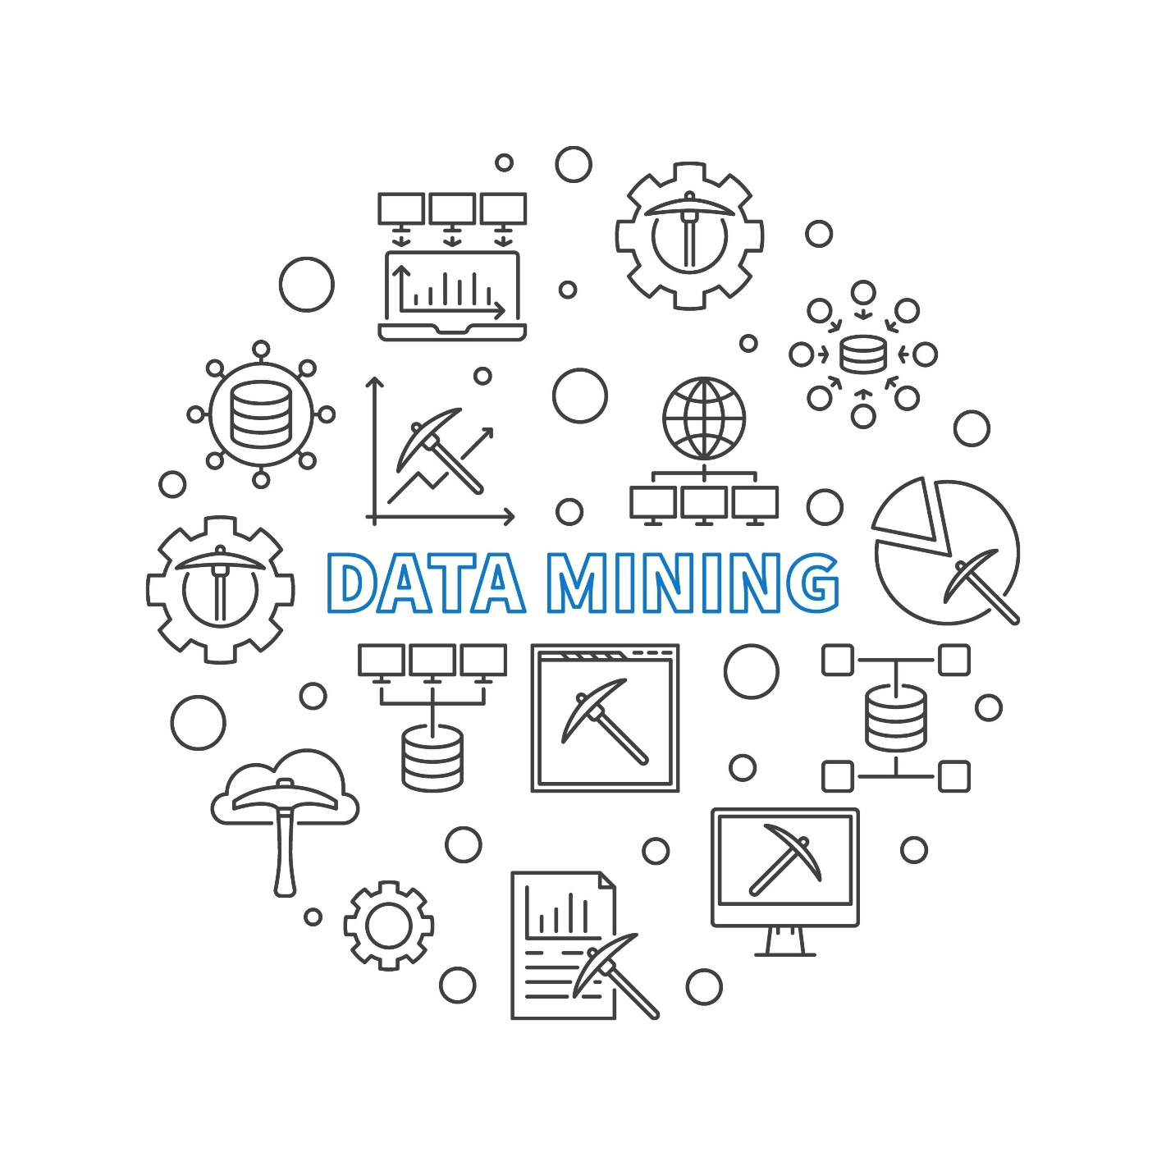
Shutterstock
Открыть

4. Arithmetic Models — "Xarajat hisob-kitobi"
"Bir kvadrat metrga 10 ta g'isht ketsa, 100 kvadratga 1000 ta ketadi". Bu — oddiy arifmetik model.
- Data Science'da bu murakkabroq bo'ladi, lekin mantiq o'sha-o'sha: "Agar dollar kursi oshsa, benzin narxi qanchaga oshishini hisoblaydigan formula".

5. Predictive Analytics — "Ob-havo ma'lumoti"
Uyingizni tomini yopmoqchisiz. Usta aytadi: "Ertaga yomg'ir yog'ishi mumkin, keling ishni indinga qoldiramiz".
- Predictive Analytics — bu o'tmishdagi belgilarga qarab (bulut, shamol), kelajakni (yomg'irni) aytib berish. Bu tibbiyotda "Kasal bo'lishingiz mumkin", biznesda esa "Savdo tushib ketishi mumkin" deb ogohlantiradi.
Xulosa:
Siz endi Data Scienceni shunchaki "raqamlar" deb emas, balki reja (strategiya), tajriba (case study) va kelajakni ko'rish (bashorat) deb tushunishingiz kerak.

Lesson Overview: Careers and Recruiting in Data Science
In the lesson "Data Science Application Domains," you'll embark on a journey to explore the vast and impactful realms where data science plays a pivotal role. This engaging module delves into various activities that shed light on the diverse applications of data science in our world today.
Dive into this lesson to discover the real-world applications that define the dynamic landscape of data science.
Asset name and type | Description
“How Can Someone Become a Data Scientist?” video | Discover the pathways to becoming a proficient data scientist, exploring the skills and knowledge required.
“Recruiting for Data Science” video | Gain insights into organizations' strategies and considerations for recruiting data science talent.
“Careers in Data Science” video | Explore the diverse career opportunities and roles available in the dynamic field of data science.
“Importance of Mathematics and Statistics for Data Science” video | Understand the fundamental role of mathematics and statistics in data science, emphasizing their significance.
“The Report Structure” reading | Delve into the intricacies of structuring reports within data science projects, enhancing your understanding of this essential aspect.
Practice quiz | Test your understanding of the previous reading.
“Infograph on Roadmap” reading | Explore an informative infographic detailing the roadmap for success in data science careers.
“Lesson Summary” video | Recap the essential takeaways from this module with a lesson summary.
Practice quiz | Take a practice quiz to evaluate how well you’ve understood the material presented in this lesson.
Glossary | Use this glossary of terms to review the terminology presented in this lesson.
Grade Quiz | Evaluate your knowledge of data science in a business setting with this graded quiz.
“Data Science in Business” Reading | Summarize your learning journey in this module, reviewing the key takeaways and insights gained.

Ushbu dars "Data Science sohasidagi karyera va ishga qabul qilish" deb nomlanadi. Bu bo‘lim siz uchun eng qiziqarli qismlardan biri bo‘lishi mumkin, chunki u "Bu sohani o‘rgansam, kelajakda kim bo‘lib ishlayman va qanday talablar bor?" degan savolga javob beradi.

1. To‘liq Tarjima: Dars Rejasi
Darsga umumiy nazar: Data Science sohasidagi karyera va ishga qabul qilish
Garchi kirish qismida avvalgi dars nomi ("Data Science Application Domains") yozilib ketgan bo'lsa-da, bu modul Data Sciencening bugungi dunyomizdagi turli xil qo‘llanilishini yoritib beruvchi faoliyatlarni o‘z ichiga oladi. Siz Data Science olamining dinamik manzarasini belgilab beruvchi real hayotdagi ilovalarni kashf etasiz.
Dars tarkibi:
Material nomi va turi | Tavsifi
“How Can Someone Become a Data Scientist?” video | Malakali Data Scientist bo‘lish yo‘llarini, talab qilinadigan ko‘nikma va bilimlarni o‘rganing.
“Recruiting for Data Science” video | Tashkilotlarning Data Science iste'dodlarini ishga olish strategiyalari va e'tibor beradigan jihatlari haqida tushunchaga ega bo‘ling.
“Careers in Data Science” video | Data Science sohasidagi turli xil karyera imkoniyatlari va rollarini (lavozimlarini) ko‘rib chiqing.
“Importance of Mathematics and Statistics for Data Science” video | Data Science uchun matematika va statistikaning fundamental rolini va ularning ahamiyatini tushuning.
“The Report Structure” reading | Data Science loyihalarida hisobotlarni tuzishning nozik jihatlarini o‘rganib, ushbu muhim jarayon haqidagi tushunchangizni oshiring.
Practice quiz | Oldingi o‘qish materialini tushunganingizni sinab ko‘ring.
“Infograph on Roadmap” reading | Data Science karyerasida muvaffaqiyatga erishishning "Yo‘l xaritasi" (Roadmap) batafsil ko‘rsatilgan infografika bilan tanishing.
“Lesson Summary” video | Ushbu moduldan olingan asosiy xulosalarni qisqacha takrorlang.
Practice & Graded Quiz | Bilimlaringizni sinash va baholash uchun testlar.
Glossary | Atamalarni takrorlash uchun lug‘at.
“Data Science in Business” Reading | Ushbu modulda o‘rganganlaringizni umumlashtiring va biznesdagi asosiy xulosalarni ko‘rib chiqing.

2. Sodda tushuntirish (Hayotiy misollar bilan)
Bu darsni "Kasb tanlash va ishga kirish qo'llanmasi" deb atash mumkin.

A. Qanday qilib Data Scientist bo'lish mumkin? (Oshpazlik misoli)
Ko'pchilik "Data Scientist bo'lish uchun faqat kod yozishni bilish kerak" deb o'ylaydi. Bu xato.
- Misol: Zo'r oshpaz bo'lish uchun faqat pichoq ishlatishni bilish yetarli emas. Siz masalliqlarni (Ma'lumotlarni), retseptlarni (Algoritmlarni) va mijozga chiroyli tortiq qilishni (Hisobot berishni) bilishingiz kerak. Bu dars sizga oshpazlik maktabiga kirish yo'llarini ko'rsatadi.

B. Ishga olish (Futbol jamoasi misoli)
Kompaniyalar ishga olayotganda nima qidiradi?
- Misol: Futbol murabbiyi jamoaga 11 ta darvozabon olmaydi. Unga hujumchi, himoyachi va yarim himoyachi kerak.
- Data Science jamoasi ham shunday: kimgadir matematika zo'r bo'lishi kerak, kimgadir biznesni tushunish, yana kimgadir esa ma'lumotni tozalash. Siz o'zingizga mos "pozitsiya"ni tanlashingiz kerak.

C. Matematika va Statistika (Uy poydevori)
Siz "Men web dasturchi emasman" degandingiz, balki matematika bilan ham oralaringiz uzoqdir. Lekin qo'rqmang.
- Misol: Chiroyli bino (AI dasturi) qurish uchun uning tagida ko'rinmas poydevor (Matematika) bo'lishi kerak. Siz poydevorni o'zingiz qo'lda quyishingiz shart emas (kompyuter buni qiladi), lekin poydevor betonmi yoki loydanmi ekanligini farqlay olishingiz kerak.

D. Hisobot tuzilmasi (Hikoya)
Biz oldingi darsda "Yakuniy natija" haqida gaplashgandik. Bu yerda o'sha hisobotni qanday yozish o'rgatiladi.
- Misol: Shifokor retsept yozganda tushunarsiz yozsa, bemor tuzalmaydi. Data Scientist ham hisobotni shunday yozishi kerakki, uni o'qigan rahbar: "Tushunarli, demak biz narxni tushirishimiz kerak ekan," degan aniq xulosaga kelsin.
Xulosa:
Bu dars sizga "Qayerdan boshlayman?", "Menga nimalar kerak?" va "Qanday qilib ish topaman?" degan savollarga aniq xarita (Roadmap) beradi.

Music A real data scientist, the high-end data scientists, are mostly PhDs. They often come out of physics, out of statistics, they have to have a computer science background, they have to have a math background, they have to know about databases and statistics and probability and all that stuff. However, if you're coming into a data science team, I think the first skills you need is you need to know how to program, at least have some computational thinking, so having taken a programing course, you need to know some algebra, at least up to analytics, geometry, and hopefully some calculus, some basic probability, some basic statistics, I mean really have to understand the difference and different statistical distributions, and database. I mean, one of the easiest places to start is relational databases, which stores lots and lots of our data so people can first walk before they can run by at least understanding about computers and databases and how we store things and if you understand relational databases nowadays you can still, just with that understanding, use big data clusters as if they were just a big relational database. You don't have to really have understand the whole MapReduce programming model. But then, as you go further up in the field, then you have to know a lot of computer science theory and statistics, it's really, and probability, it's really the intersection of them that the high end data scientists, the PhD data scientists work with. (music) I do a lot of self-learning. I think everybody these days, I mean, I learned about Hadoop all by myself, I read some articles, I watched some videos, I thought, I played, although I'm a builder, I'm a tinkerer, so if I wanna figure out how to do something, I build it.
I mean, my first HPC cluster I heard about this term a Beowulf cluster, I mean, yeah, what the hell's that? So I looked it up and said, oh, it's just a bunch of computers hooked together with a TCP/IP network, that's pretty easy, so we get a grant from Citi Bank and we built a five thing cluster and I said, oh, well, that's HPC. I said, I had one of the first HPC clusters at the university, it was tiny but a lot of our researchers loved it because they could run stuff 40 and 50 times faster. So I think one of the ways you learn things is you do them, you have to do them, and these online learning platforms especially now that we have things like IPython and Jupyter Notebooks and I guess Zeppelin means that you can actually go in and take some of these courses and you can do things right then and you can see them and feel them and play with them and, at that point, you know, you'll start to get your head around what is actually happening. Motivation is the key problem in all of these, is how to keep people motivated and I think the badge system that the, what was it, Big Data University has, is one of the ways is how do you get people to keep going through. But if they want to, they can. It's up to the individual to.
So they have to understand what the goal is. (music) The place it can't sit is probably under the CIO, the Chief Information Officer. CIOs current chief information officers in many companies got there from an accounting background or a finance background, they're clueless. Sorry. But they really, it has to come out of the research side. So you'll find data scientists primarily in companies that have some research agenda, pharmaceuticals, finance, all of, any technology company. If you look at, we can't keep some of our PhD data scientists in our program, they are now at Facebook, they're at Linkedin, they're at Uber, they're at Lyft, because the demand out there for the PhD level data scientist is just unbelievable. They make large amounts of money and they're playing with problems that are really, really neat.
How do you schedule the Uber cars? You have enormous amounts of data. (music)

Ushbu videotranskriptda Data Scientist bo‘lish uchun nimalar kerakligi, qanday o‘rganish lozimligi va bu kasb egalari kompaniyaning qaysi qismida joylashishi kerakligi haqida so‘z boradi.

1. To‘liq Tarjima: Haqiqiy Data Scientist kim?
Haqiqiy Data Scientistlar, ya'ni eng yuqori darajadagi mutaxassislar asosan fan doktorlari (PhD) hisoblanadi. Ular ko‘pincha fizika yoki statistikadan chiqishadi. Ularda kompyuter fanlari bo‘yicha bilim, matematika, ma'lumotlar bazasi, statistika va ehtimollar nazariyasi kabi barcha narsalar bo‘lishi shart.
Biroq, agar siz Data Science jamoasiga endi kirib kelayotgan bo‘lsangiz, menimcha, birinchi navbatda dasturlashni bilishingiz kerak (hech bo‘lmaganda bitta kursni tugatgan bo‘lishingiz lozim). Shuningdek:
- Algebra va Geometriya;
- Oliy matematika (Calculus) va tahlil asoslari;
- Boshlang‘ich ehtimollar nazariyasi va statistika (turli taqsimotlarni farqlay olish);
- Ma'lumotlar bazasi (Database).
Boshlash uchun eng oson joy — bu Relyatsion ma'lumotlar bazasi (jadvallar). Agar siz ma'lumotlar qanday saqlanishini va bazalar qanday ishlashini tushunsangiz, hozirgi "Big Data Cluster"larini ham xuddi katta jadvallar kabi ishlatishingiz mumkin. Murakkab "MapReduce" modellarini tushunishingiz shart emas. Lekin martabangiz oshgani sayin, kompyuter nazariyasi va statistikani chuqurroq o‘rganishingizga to‘g‘ri keladi.
Mustaqil o‘rganish (Self-learning):
Men o‘zim ko‘p narsani mustaqil o‘rganaman. Masalan, Hadoop texnologiyasini maqolalar o‘qib, videolar ko‘rib o‘rgandim. Men "quruvchi" va "kavlashtiruvchi" (tinkerer) toifasidagi odamman. Biror narsani tushunish uchun uni qurib ko‘rishim kerak.
Masalan, birinchi marta "HPC Cluster" (Superkompyuter) degan so‘zni eshitganimda, "Bu nima balo?" dedim. Qidirsam, bu shunchaki bir-biriga ulangan kompyuterlar ekan. Biz bankdan grant oldik va 5 ta kompyuterni ulab, kichik klaster yasadik. Bu universitetdagi birinchi klasterlardan edi va olimlarimiz buni juda yaxshi ko‘rishdi, chunki hisob-kitoblar 50 barobar tezlashdi.
O‘rganishning eng yaxshi yo‘li — qilib ko‘rishdir. Hozir Jupyter Notebook kabi vositalar bor, siz kursni ko‘rib, o‘sha zahotiyoq kod yozib, natijani ko‘rishingiz va "o‘ynab ko‘rishingiz" mumkin. Motivatsiya — bu yerdagi asosiy muammo.
Kompaniyadagi o‘rni:
Data Scientistlar CIO (Bosh Axborot Direktori) qo‘l ostida o‘tirmasligi kerak. Ko‘p CIOlar buxgalteriya yoki moliya fonidan chiqqan bo‘ladi va ular bu sohani tushunmaydi. Data Science Tadqiqot (Research) bo‘limidan chiqishi kerak.
Shuning uchun siz haqiqiy Data Scientistlarni farmatsevtika, moliya yoki texnologiya kompaniyalarida (Facebook, Uber, Lyft) ko‘rasiz. U yerdagi talab shunchalik kuchliki, biz universitetda fan doktorlarini olib qololmayapmiz, ular katta maosh va qiziqarli muammolar (masalan, Uber mashinalarini qanday taqsimlash) uchun ketib qolishmoqda.

2. Sodda tushuntirish (Siz uchun maxsus)
Bu videoda Data Scientist bo‘lish yo‘li xuddi Avtomobil ustasi bo‘lishga o‘xshatilgan.

A. "Havaskor usta" vs "Muhandis" (Data Scientist darajalari)
- Boshlang‘ich daraja: Siz mashinaning g‘ildiragini almashtirishni, moyini tekshirishni va oddiy kalitlarni (Dasturlash, Algebra, Excel/Baza) ishlatishni bilishingiz kerak. Bu yetarli.
- Yuqori daraja (PhD): Bu endi shunchaki usta emas, balki Ferrari motorini noldan yig‘adigan muhandis. U fizika qonunlarini, metallning chidamliligini (Oliy matematika, Statistika) bilishi shart.
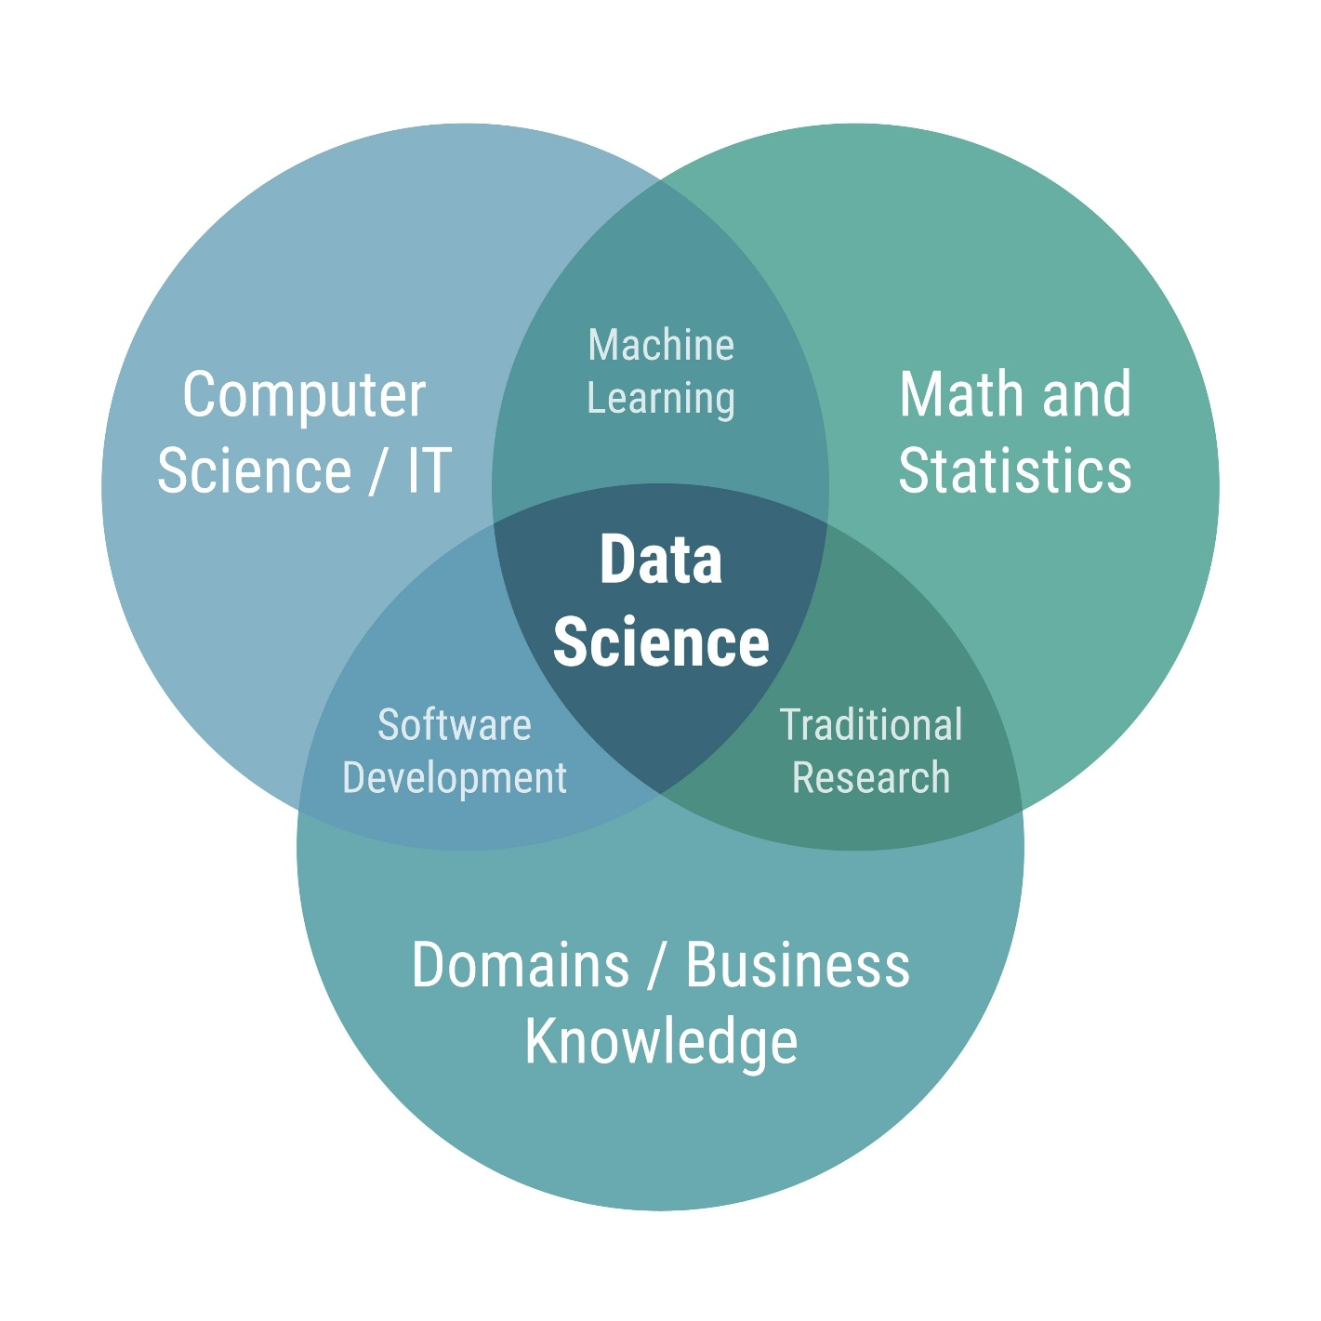
Shutterstock
Открыть

B. Qanday o‘rganish kerak? (Qo‘lni moy qilish)
Spiker aytyaptiki: "Kitob o‘qib suzishni o‘rganib bo‘lmaydi".
- U "Superkompyuter" yasamoqchi bo‘lganda, shunchaki 5 ta eski kompyuterni bir-biriga kabel bilan ulab ko‘rgan. Buzib qo‘yishdan qo‘rqmagan.
- Siz uchun Jupyter Notebook degan narsa bor. Bu xuddi "Virtual Garaj". U yerda siz kod yozib xato qilsangiz ham, kompyuteringiz portlab ketmaydi. Bemalol "kavlashtirib" o‘rganishingiz mumkin.

C. Qayerda ishlash kerak? (Buxgalterga bo‘ysunmang)
Bu juda qiziq nuqta.
- CIO (Bosh Axborotchi): Odatda kompaniyaning pullarini tejashni va kompyuterlar buzilmasdan ishlashini xohlaydi (Buxgalter tabiati).
- Data Scientist: Yangilik yaratishni, tajriba o‘tkazishni xohlaydi (Olim tabiati).
- Agar Olim Buxgalterga bo‘ysunsa, ish yurishmaydi. "Nega qimmat kompyuter olding?", "Nega natija darrov chiqmadi?" deb tergayveradi. Shuning uchun Data Scientistlar Uber yoki Facebook kabi "Miya markazlari"da ishlaydi. U yerda ularga: "Mana senga pul, bizga yangi narsa o‘ylab top (masalan, taksi narxini to‘g‘ri hisoblaydigan formula)", deyishadi.

3. Asosiy terminlar
- PhD (Philosophy Doctor): Fan doktori. O‘z sohasining eng yuqori darajadagi olimi.
- Relational Database (Relyatsion baza): Ma'lumotlarning tartibli jadvallarda saqlanishi (Excelga o‘xshash, lekin juda katta).
- HPC / Cluster: Yuzlab oddiy kompyuterlarning birlashib, bitta super-kuchli kompyuterga aylanishi.
- Jupyter Notebook: Data Scientistlar kod yozadigan, natijani ko‘radigan va matn yozadigan maxsus "daftar" dasturi.
Xulosa:
Sizdan darhol "Olim" bo‘lish talab qilinmaydi. Hozircha "Garaj"ga kirib (Jupyter Notebook), qo‘lingizni ozgina "moy" qilsangiz (kod yozib ko‘rsangiz) kifoya.

Recruiting for Data Science
[MUSIC] When the companies are hiring people for a data science team, maybe a data scientist or an analyst, or a chief data scientist, the tendency would be to find the person who has all the skills, that they know the domain-specific knowledge. They're excellent in analyzing structured and unstructured data. And they're great at presenting and they've got great storytelling skills. So if you put all this together, you will realize you're looking for a unicorn. And your odds of finding a unicorn are pretty rare. I think what you need to do to is to see, given the pool of applicants you have, who has the most resonance with your firm's DNA. Because you can teach analytics skills, anyone can learn analytics skills if they dedicate time and effort to it.
But what really matters is who's passionate about the kind of business that you do. Someone could be a great data scientist in the retail environment, but they may not be that excited about working in IT related firms or working with gigabytes of weblogs. But if someone is excited about those weblogs, if someone is excited about health-related data then they would be able to contribute to your productivity much more so. And I would say if I'm looking for someone, if I have to put together a data science team, I would first look for curiosity. Is that person curious about things not just for data science but anything like, are they curious about why this room is painted a certain way, why do the bookshelves have books, and what kinds of books? They have to have a certain degree of curiosity about everything that is in their vision, that they look at. The second thing is do they have a sense of humor because, you see, you have to have a lighthearted about it.
If someone is too serious about it, they probably would take it too seriously, and would not be able to look at the lighter elements. The third thing I think, and I think the last thing that I would look for if I had to have a hierarchy, the last thing I would look for are technical skills. I would go through the social skills, curiosity, and sense of humor. The ability to tell a story. The ability to know that there is a story there. And then once all is there then I would say, well, can you do the technical side of it? And if there is some hope or some sign of some technical skills, I would take them because I can train them in whatever skills they need.
But I cannot teach curiosity. I cannot teach storytelling. I cannot certainly, instill sense of humor in anyone. I think there's no hard and fast rule for hiring data scientists. I think it's going to be a case by case thing. I would say there has to be some sort of technical component, somebody should be able to work with and manipulate the data. They should be able to communicate what they find in the data.
I find quite often nobody really cares about the r-square or the confidence interval. So you have to be able to introduce those things and explain something in a compelling way. And they also have to find somebody who is relatable, because data science, it been typically new means that the person in that role has to make relationships and they have to work across different departments. If these data scientist has a good mathematics and statistics background. They have to consider like problem solving abilities and analysis. The scientist needs to be good in analyzing problems. The persons they are hiring, they should love to play with data.
And then they know how to play with the data visualization. They have analytical thinking. When a company is hiring anyone to work on a data science team, they need to think about what role that person is going to take. Before a company begins, they need to understand what they want out of their data science team. And then they need to hire to begin it. As they grow a data science team, they need to understand whether they need engineers, architects, designers to work on visualization. Or whether they just need more people who can multiply large matrices.
From a skills point of view, let's focus on the technical skills and in that case, first thing would be what kind of a technical platform would you like to adopt? Let's say you want to work in a structured data environment and let's say you want to work in market research. Then the type of skills you need are slightly different than someone who would like to work in big data environments. If you want to work in the traditional market research data, structure data environment, your skills should be some statistical knowledge and some knowledge of basic statistical algorithms, maybe some machine learning algorithms. And these are the tools that you would like to develop. If you want to work in big data, then there's the other aspect of it and that is to be able to store data. So you start with the expertise in storing large amounts of data.
And then you look into platforms that allow you to do that. The next step would be to be able to manipulate large amounts of data, and the final step would be to apply algorithms to those large sets of data. So it's a three-step process. But most likely it starts, most importantly, it starts with where you would like to be, in what field, in what domain. In terms of platforms, let's you want to be in the traditional predictive analytics environment, and you're not working with big data, then R or Stata, or Python would be your tools. If you're working mostly with unstructured data, then Python is most suitable than R. If you're working with big data, then Hadoop and Spark are the environments that you will be working with.
So it all depends upon where you would like to be and what kind of work excites you and then you pick your tools. In addition to technical skills, the second aspect of the data science is to have the ability to communicate. The communication skills or presentation skills. I call them story telling skills, that is that you have your analysis done, now can you tell a great story from it? If you have a very large table, can you synthesize this and make it more appealing that when it goes on the screen, or is it part of a document that it just speaks? It sings the findings and the reader just gets it right there. So the ability to present your findings, either verbally, or in a presentation, or in a document.
So those communication and presentation skills are equally important as the technical skills are. When you have a grading side, when you're presenting your results, imagine you're driving on a mountain and then there's a sharp turn. And you can't see what's beyond the turn. And then you make that turn and then suddenly, you see a tremendous valley in front of you. And this great sense of awe, that I didn't know that, right? So when you present your findings and you have this great finding and you communicate it well, this is what people feel because they were not expecting it. They were not aware of it, and then this great sense of happiness that now I know.
And I didn't know this, now I know. And then it empowers them, it gives them ideas, what they can do with this knowledge, this new insight. It's a great sense of joy. And you are able as a data scientist, you are able to share with your clients because you enabled it. [MUSIC]

Ushbu videotranskriptda Data Scientist bo‘lish uchun nimalar kerakligi, qanday o‘rganish lozimligi va bu kasb egalari kompaniyaning qaysi qismida joylashishi kerakligi haqida so‘z boradi.

1. To‘liq Tarjima: Haqiqiy Data Scientist kim?
Haqiqiy Data Scientistlar, ya'ni eng yuqori darajadagi mutaxassislar asosan fan doktorlari (PhD) hisoblanadi. Ular ko‘pincha fizika yoki statistikadan chiqishadi. Ularda kompyuter fanlari bo‘yicha bilim, matematika, ma'lumotlar bazasi, statistika va ehtimollar nazariyasi kabi barcha narsalar bo‘lishi shart.
Biroq, agar siz Data Science jamoasiga endi kirib kelayotgan bo‘lsangiz, menimcha, birinchi navbatda dasturlashni bilishingiz kerak (hech bo‘lmaganda bitta kursni tugatgan bo‘lishingiz lozim). Shuningdek:
- Algebra va Geometriya;
- Oliy matematika (Calculus) va tahlil asoslari;
- Boshlang‘ich ehtimollar nazariyasi va statistika (turli taqsimotlarni farqlay olish);
- Ma'lumotlar bazasi (Database).
Boshlash uchun eng oson joy — bu Relyatsion ma'lumotlar bazasi (jadvallar). Agar siz ma'lumotlar qanday saqlanishini va bazalar qanday ishlashini tushunsangiz, hozirgi "Big Data Cluster"larini ham xuddi katta jadvallar kabi ishlatishingiz mumkin. Murakkab "MapReduce" modellarini tushunishingiz shart emas. Lekin martabangiz oshgani sayin, kompyuter nazariyasi va statistikani chuqurroq o‘rganishingizga to‘g‘ri keladi.
Mustaqil o‘rganish (Self-learning):
Men o‘zim ko‘p narsani mustaqil o‘rganaman. Masalan, Hadoop texnologiyasini maqolalar o‘qib, videolar ko‘rib o‘rgandim. Men "quruvchi" va "kavlashtiruvchi" (tinkerer) toifasidagi odamman. Biror narsani tushunish uchun uni qurib ko‘rishim kerak.
Masalan, birinchi marta "HPC Cluster" (Superkompyuter) degan so‘zni eshitganimda, "Bu nima balo?" dedim. Qidirsam, bu shunchaki bir-biriga ulangan kompyuterlar ekan. Biz bankdan grant oldik va 5 ta kompyuterni ulab, kichik klaster yasadik. Bu universitetdagi birinchi klasterlardan edi va olimlarimiz buni juda yaxshi ko‘rishdi, chunki hisob-kitoblar 50 barobar tezlashdi.
O‘rganishning eng yaxshi yo‘li — qilib ko‘rishdir. Hozir Jupyter Notebook kabi vositalar bor, siz kursni ko‘rib, o‘sha zahotiyoq kod yozib, natijani ko‘rishingiz va "o‘ynab ko‘rishingiz" mumkin. Motivatsiya — bu yerdagi asosiy muammo.
Kompaniyadagi o‘rni:
Data Scientistlar CIO (Bosh Axborot Direktori) qo‘l ostida o‘tirmasligi kerak. Ko‘p CIOlar buxgalteriya yoki moliya fonidan chiqqan bo‘ladi va ular bu sohani tushunmaydi. Data Science Tadqiqot (Research) bo‘limidan chiqishi kerak.
Shuning uchun siz haqiqiy Data Scientistlarni farmatsevtika, moliya yoki texnologiya kompaniyalarida (Facebook, Uber, Lyft) ko‘rasiz. U yerdagi talab shunchalik kuchliki, biz universitetda fan doktorlarini olib qololmayapmiz, ular katta maosh va qiziqarli muammolar (masalan, Uber mashinalarini qanday taqsimlash) uchun ketib qolishmoqda.

2. Sodda tushuntirish (Siz uchun maxsus)
Bu videoda Data Scientist bo‘lish yo‘li xuddi Avtomobil ustasi bo‘lishga o‘xshatilgan.

A. "Havaskor usta" vs "Muhandis" (Data Scientist darajalari)
- Boshlang‘ich daraja: Siz mashinaning g‘ildiragini almashtirishni, moyini tekshirishni va oddiy kalitlarni (Dasturlash, Algebra, Excel/Baza) ishlatishni bilishingiz kerak. Bu yetarli.
- Yuqori daraja (PhD): Bu endi shunchaki usta emas, balki Ferrari motorini noldan yig‘adigan muhandis. U fizika qonunlarini, metallning chidamliligini (Oliy matematika, Statistika) bilishi shart.
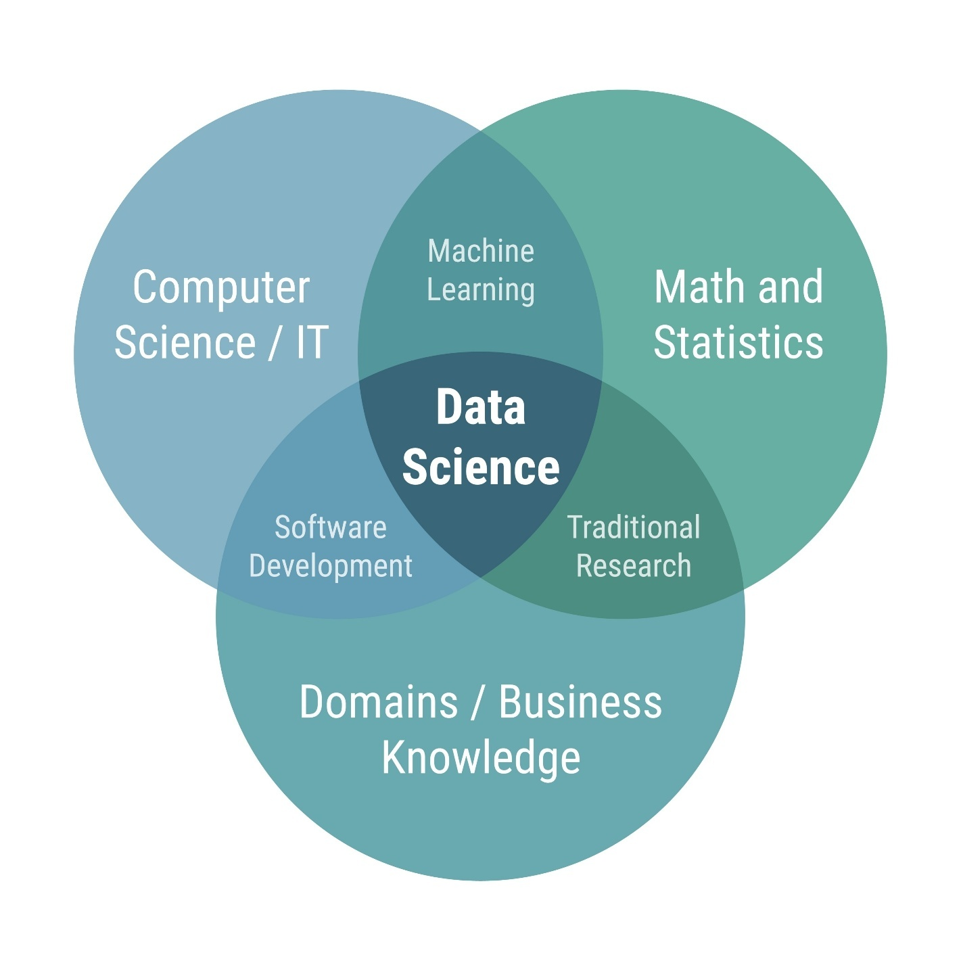

B. Qanday o‘rganish kerak? (Qo‘lni moy qilish)
Spiker aytyaptiki: "Kitob o‘qib suzishni o‘rganib bo‘lmaydi".
- U "Superkompyuter" yasamoqchi bo‘lganda, shunchaki 5 ta eski kompyuterni bir-biriga kabel bilan ulab ko‘rgan. Buzib qo‘yishdan qo‘rqmagan.
- Siz uchun Jupyter Notebook degan narsa bor. Bu xuddi "Virtual Garaj". U yerda siz kod yozib xato qilsangiz ham, kompyuteringiz portlab ketmaydi. Bemalol "kavlashtirib" o‘rganishingiz mumkin.

C. Qayerda ishlash kerak? (Buxgalterga bo‘ysunmang)
Bu juda qiziq nuqta.
- CIO (Bosh Axborotchi): Odatda kompaniyaning pullarini tejashni va kompyuterlar buzilmasdan ishlashini xohlaydi (Buxgalter tabiati).
- Data Scientist: Yangilik yaratishni, tajriba o‘tkazishni xohlaydi (Olim tabiati).
- Agar Olim Buxgalterga bo‘ysunsa, ish yurishmaydi. "Nega qimmat kompyuter olding?", "Nega natija darrov chiqmadi?" deb tergayveradi. Shuning uchun Data Scientistlar Uber yoki Facebook kabi "Miya markazlari"da ishlaydi. U yerda ularga: "Mana senga pul, bizga yangi narsa o‘ylab top (masalan, taksi narxini to‘g‘ri hisoblaydigan formula)", deyishadi.

3. Asosiy terminlar
- PhD (Philosophy Doctor): Fan doktori. O‘z sohasining eng yuqori darajadagi olimi.
- Relational Database (Relyatsion baza): Ma'lumotlarning tartibli jadvallarda saqlanishi (Excelga o‘xshash, lekin juda katta).
- HPC / Cluster: Yuzlab oddiy kompyuterlarning birlashib, bitta super-kuchli kompyuterga aylanishi.
- Jupyter Notebook: Data Scientistlar kod yozadigan, natijani ko‘radigan va matn yozadigan maxsus "daftar" dasturi.
Xulosa:
Sizdan darhol "Olim" bo‘lish talab qilinmaydi. Hozircha "Garaj"ga kirib (Jupyter Notebook), qo‘lingizni ozgina "moy" qilsangiz (kod yozib ko‘rsangiz) kifoya.

Careers in Data Science
[MUSIC] The emergence of Internet of things and advances in distributed computing have brought vast amounts of data and the technological capability to analyze it. Now that we can extract useful insights and new knowledge, we need to know how to shape that data to focus on what to do with it and what it can do for us. Enter data science. Companies like LinkedIn, Glassdoor, Indeed, and Dice track employment trends which show a career in data science moving up the list of most promising jobs to become number one since 2016. It remains one of the top three career choices for 2020. Dice noted that job postings are from companies in a wide variety of industries, not just tech. Global Industry Analysts Incorporated predicts that the data science platform market will grow by $314.8 billion US by 2025, driven by a compounded growth of 38.2%.
McKinsey Global Institute warned of huge talent shortages for data and analytics by 2018. Forrester Research Analyst Brandon Purcell said, in January of 2019, the demand for data scientists will only grow as organizations increasingly rely on data-driven insights. We're now well into that period, and recruiters are finding it difficult to fill the growing need for talented data scientists. What motivates someone going into a data science career? For one thing, data science applies to almost any discipline. So if you have the aptitude and desire to work with data, enjoy coding, have no problem learning math and statistics, and you are a good storyteller, then you can certainly enter a data science field and excel. For most people, this means acquiring additional tools and skills and continuously learning about new tools and techniques in the field.
The women in data science initiative spearheaded by the Stanford Institute for Computational and Mathematical Computing have committed to inspire and educate data scientists worldwide, regardless of gender and to support women in the field. When you are seeking a career in data science, you need to make sure your skill set matches the role you are targeting. You can tailor your skill set to the specific area you want to enter, adding missing skills via one of the many excellent online training resources. Then you'll be prepared for a fascinating and rewarding career. So now it is time to move into this field, when there are such diverse choices available and education resources that make it a reality. [MUSIC]

Ushbu videotranskript Data Science sohasidagi karyera imkoniyatlari haqida. Unda nima uchun bu kasb bugungi kunda dunyodagi eng talabgir kasblardan biri ekanligi va unga kirish uchun nimalar kerakligi tushuntirilgan.

1. To‘liq Tarjima: Data Science karyerasi
Narsalar interneti (IoT) ning paydo bo‘lishi va taqsimlangan hisoblash tizimlaridagi yutuqlar katta hajmdagi ma'lumotlarni va ularni tahlil qilish uchun texnologik imkoniyatlarni olib keldi. Endi biz foydali tushunchalar va yangi bilimlarni ajratib olishimiz mumkin ekan, biz bu ma'lumotlarni qanday shakllantirishni va undan nima maqsadda foydalanishni bilishimiz kerak. Shu yerda sahnaga Data Science kirib keladi.
LinkedIn, Glassdoor, Indeed va Dice kabi kompaniyalar ish bilan bandlik tendensiyalarini kuzatib boradilar va bu Data Science sohasidagi karyeraning 2016-yildan beri eng istiqbolli ishlar ro‘yxatida yuqorilab, birinchi o‘ringa chiqqanini ko‘rsatmoqda. U 2020-yil uchun ham eng yaxshi uchta karyera tanlovidan biri bo‘lib qolmoqda. Dice ta'kidlashicha, ish e'lonlari nafaqat texnologiya kompaniyalaridan, balki turli xil sohalardan kelmoqda.
Global tahlilchilarning bashoratiga ko‘ra, Data Science platformasi bozori 2025-yilga kelib 38,2% yillik o‘sish hisobiga 314,8 milliard dollarga yetadi. McKinsey Global instituti 2018-yilga kelib ma'lumotlar va tahlil bo‘yicha ulkan kadrlar yetishmovchiligi bo‘lishidan ogohlantirgan edi. Forrester tahlilchisi Brendon Pursel 2019-yilda tashkilotlar ma'lumotlarga asoslangan tushunchalarga tobora ko‘proq tayanayotgani sababli Data Scientistlarga bo‘lgan talab faqat o‘sishini aytdi.
Biz hozir o‘sha davrning ichidamiz va yollovchilar (rekruiterlar) o‘sib borayotgan ehtiyojni qondirish uchun iste'dodli Data Scientistlarni topishda qiynalishmoqda.
Motivatsiya nima?
Birinchidan, Data Science deyarli har qanday sohaga tatbiq etiladi. Agar sizda ma'lumotlar bilan ishlashga ishtiyoq bo‘lsa, kodlashni yoqtirsangiz, matematika va statistikani o‘rganishda muammo bo‘lmasa va siz yaxshi hikoyachi (storyteller) bo‘lsangiz, unda siz ushbu sohaga kirishingiz va muvaffaqiyat qozonishingiz mumkin. Ko‘pchilik uchun bu qo‘shimcha vositalar va ko‘nikmalarni o‘rganishni anglatadi.
Ayollar Data Science sohasida:
Stenford instituti boshchiligidagi "Women in Data Science" (Ayollar Data Scienceda) tashabbusi jinsidan qat'i nazar, butun dunyo bo‘ylab ma'lumotshunoslarni ilhomlantirish va o‘qitishga bag‘ishlangan.
Agar siz ushbu sohada ishlamoqchi bo‘lsangiz, ko‘nikmalaringiz siz maqsad qilgan rolga mos kelishiga ishonch hosil qiling. Yetishmayotgan bilimlarni onlayn kurslar orqali to‘ldirib, o‘zingizni qiziqarli va daromadli karyeraga tayyorlashingiz mumkin. Hozir bu sohaga kirishning ayni vaqti.

2. Sodda tushuntirish (Karyera bo‘yicha maslahat)
Keling, bu videoni oddiy "Oltin vasvasasi" misolida tushunamiz.

A. "Oltin konlari" va "Konchilar yetishmovchiligi"
Hozirgi dunyoda ma'lumot — bu yangi oltin.
- Kompaniyalar (Banklar, Do‘konlar, Kasalxonalar) yer tagida (serverlarda) tonnalab oltin (ma'lumot) yotganini bilishadi.
- Muammo: Bu oltinni qazib olib, tozalab, zargarlik buyumiga aylantiradigan ustalar (Data Scientistlar) juda kam.
- Natija: Ustalar kam bo‘lgani uchun, ularning maoshi baland va ish topishi oson. Hatto oddiy firmalar ham "Bizga ham bitta usta kerak" deb qidirib yurishibdi.

B. Kimlar "Usta" bo‘la oladi? (Shveytsariya pichog‘i)
Data Scientist bo‘lish uchun sizda "Shveytsariya pichog‘i" kabi ko‘p qirrali qobiliyat bo‘lishi kerak:
- Kodlash: Kompyuter bilan gaplasha olish (Pichoq).
- Matematika/Statistika: Hisob-kitobni bilish (Qaychi).
- Hikoyachilik (Storytelling): Rahbarga natijani tushuntirib berish (Ochqich).
Agar sizda shu uchtasi bo‘lsa (yoki o‘rganishga xohish bo‘lsa), siz "Xazina"siz.

C. Faqat "Kompyuterchilar" uchun emas
Video muhim narsani aytdi: "Ayollar Data Science sohasida".
- Bu soha faqat "qorong‘u xonada o‘tiradigan yigitlar" uchun emas. Ayollar ham bu sohada juda muvaffaqiyatli bo‘lishmoqda va maxsus qo‘llab-quvvatlash dasturlari (Stenford tashabbusi kabi) mavjud.

3. Asosiy terminlar
- Internet of Things - IoT (Narsalar interneti): Internetga ulangan buyumlar (Aqlli soat, aqlli muzlatgich, mashinalar). Ular tinimsiz ma'lumot ishlab chiqaradi.
- Distributed Computing (Taqsimlangan hisoblash): Katta vazifani bitta kompyuterda emas, balki yuzlab kompyuterlarga bo‘lib bajarish.
- Talent Shortage (Iste'dodlar yetishmovchiligi): Ish o‘rinlari ko‘p, lekin mutaxassislar yetarli emasligi.
- Storyteller (Hikoyachi): Data Science'da bu — murakkab raqamlarni oddiy odam tushunadigan tilga o‘girib beradigan mutaxassis.
Xulosa:
Hozir Data Science sohasiga kirish uchun eng zo‘r vaqt. Bozor o‘syapti, ish ko‘p, raqobat (mutaxassislar orasida) hali unchalik kuchli emas. Asosiysi — o‘rganishdan to‘xtamaslik.

Importance of Mathematics and Statistics for Data Science
(Music) Learn how to program. Learn some math. Take a course in probability. Learn a little bit of statistics. And then, play. Build something, write something. I mean, when I say build, programming and building systems, building things isn't just physical, right?
You can build computer systems, statistical systems, whatever. But once you try to do something, then you'll know what tools you need, right? And you'll say, "Oh, oh my god, what? "There's this expression there, "what does an inner product mean? "What's that? "How do I, oh, okay, I can learn that." And then when they get to college, they will have a big jump on many of the other college students.
And so when they get out of college, they'll have an even bigger jump, and then make a lot of money. And they'll be happy, too. This stuff is fun, right? It's fun. If you're in high school and you're considering data science, I would say get familiar with data bases, start learning SQL, start thinking about, you know, computer science, if that's interesting. If you have a computer science course in your school, you know, take it, and that's a good part of being a data scientist. Beyond that there are probably ways to foster your creativity, right, your curiosity.
If you like detective games, that's kind of cool, right. And if you like treasure hunts or whatever, right, if you're into that stuff, I think you'll, and you get the opportunity to do that stuff, that will help you as a data scientist because it's a really a good way to kind of make sure that you can be curious as you go about your daily life. (Music) Encourage the curiosity, encourage the experimentation. It's kind of like science fairs, science fairs are great, they encourage that experimentation, that learning from, asking a question and answering it through a scientific method, but doing that with data sets rather than vinegar volcanoes. It's kind of the same thing, but learning from data and we're going through an election season right now, there's a lot of stuff in the news about polls and survey results and that's a great way to start a conversation and talk about how do the people who ran the polls, how do they know, how can they predict what's going to happen in the election. So that's another cool way to start a conversation about data science. (Music) I would say encourage the person who is interested in data science because to pursue to, because it's a great career and it is something that is definitely going to be in need in the future.
It's one of those highly sought after knowledge professions that are really important to businesses around the world. So being a data scientist and being able to help companies as they grow and learn how do to things more efficiently or how to do things smarter, there will always be a need for people like that. And data scientists are those people. (Music) I would say that I understand what you're talking about because I was never a great mathematics student as well. And I think there's actually a bunch of data scientist, who are really successful and popular, who are in the same boat. You know there's kind of arithmetic and math in school is not necessarily everybody's best subject. But when you combine it with, you know these aren't just hypothetical numbers, these aren't just, problem statements that you have no connection to.
When you have a connection to the problem, it suddenly becomes much easier to use math to help understand it, I found. And so you know, knowing the people who will benefit from the math that you do I think is really cool. (Music)

Ushbu videotranskript Data Science sohasiga qiziqqan yoshlar (maktab o'quvchilari) va talabalar uchun maslahatlar to'plamidir. Unda matematikadan qo‘rqish kerak emasligi va bu kasb qanchalik qiziqarli ekanligi haqida gapiriladi.

1. To‘liq Tarjima: Yoshlar uchun maslahatlar
Dasturlashni o‘rganing. Biroz matematika o‘rganing. Ehtimollar nazariyasi bo‘yicha kurs oling. Statistikaning boshlang‘ich qismini o‘zlashtiring.
Keyin esa o‘ynang. Biror narsa quring, yozing. Men "qurish" deganda faqat jismoniy narsalarni emas, balki kompyuter tizimlarini, statistik tizimlarni nazarda tutyapman.
Biror narsa qilishga urinib ko‘rganingizdan keyingina sizga qaysi vositalar kerakligini tushunasiz. Shunda: "Voy xudoyim, bu nima? 'Ichki ko‘paytma' (inner product) nima degani? Qanday qilib... Ha, mayli, men buni o‘rganib olaman," deysiz.
Kollejga borganingizda boshqa talabalardan ancha oldinda bo‘lasiz. O‘qishni bitirganingizda esa yanada katta ustunlikka ega bo‘lasiz va ko‘p pul topasiz. Hamda baxtli bo‘lasiz, chunki bu ish qiziqarli.
Maktab o‘quvchilari uchun:
Agar maktabda o‘qisangiz va Data Science haqida o‘ylayotgan bo‘lsangiz, ma'lumotlar bazasi bilan tanishing, SQLni o‘rganishni boshlang. Agar maktabingizda informatika darsi bo‘lsa, albatta qatnashing.
Bundan tashqari, qiziquvchanligingizni oshiring. Agar sizga detektiv o‘yinlar yoki xazina izlash yoqsa, bu juda zo‘r. Bu narsalar Data Scientist bo‘lishingizga yordam beradi, chunki bu kundalik hayotda qiziquvchan bo‘lishingizni ta'minlaydi.
Tajriba (Eksperiment) qilish:
Qiziquvchanlik va tajribani rag‘batlantirish kerak. Bu xuddi maktabdagi ilmiy yarmarkalarga o‘xshaydi: savol berish va unga ilmiy usul bilan javob topish. Faqat bu yerda siz "sirka vulqonlari" (oddiy maktab tajribasi) o‘rniga ma'lumotlar to‘plami bilan ishlaysiz.
Masalan, hozir saylov mavsumi. Yangiliklarda so‘rovnomalar (polls) haqida ko‘p gapiriladi. Bu Data Science haqida suhbat boshlash uchun ajoyib mavzu: "So‘rovnoma o‘tkazganlar natijani qayerdan bilishadi? Qanday qilib saylov natijasini oldindan aytish mumkin?".
Karyera va Matematika qo‘rquvi:
Data Science — bu kelajakda ham juda kerak bo‘ladigan, yuqori talabga ega kasb. Kompaniyalarga aqlliroq va samaraliroq ishlashga yordam beradigan odamlarga doim ehtiyoj bo‘ladi.
Agar matematikadan zo‘r bo‘lmasangiz, tushunaman. Men ham matematikadan a'lochi emasdim. Ko‘plab muvaffaqiyatli Data Scientistlar ham shu ahvolda bo‘lishgan. Maktabdagi quruq raqamlar zerikarli bo‘lishi mumkin. Lekin qachonki siz real muammoni yechayotganingizda, matematika birdaniga oson va tushunarli bo‘lib qoladi. Chunki siz bu hisob-kitob kimga foyda keltirishini ko‘rib turasiz.

2. Sodda tushuntirish (O‘xshatishlar bilan)

A. "Quruvchi bo‘lish uchun g‘isht terishni boshlang"
Spiker aytyaptiki: "Avval hamma nazariyani yodlab, keyin ish qilaman demang".
- Teskari yondashuv: Oldin biror narsa (masalan, o‘yin yoki kichik dastur) yasashga urinib ko‘ring. O‘sha jarayonda qayerda bilim yetishmayotganini (masalan, hisob-kitobda xato borligini) tushunasiz va aynan o‘sha kerakli joyini o‘rganasiz. Bu eng tez o‘rganish usuli.

B. "Sherlok Holms"
Data Scientist — bu zamonaviy detektiv.
- Detektiv barmoq izlarini qidirsa, siz ma'lumotlar ichidan "izlarni" qidirasiz.
- Agar sizga jumboqlarni yechish, yashiringan narsani topish yoqsa, demak bu kasb siz uchun.

C. "Sirka vulqoni" emas, "Raqamli tajriba"
Maktabda kimyo darsida sirka va sodani aralashtirib vulqon yasagansiz. Bu qiziq, lekin bir marta portlaydi va tugaydi.
- Data Science tajribasi esa: "Nega kecha Instagramda shu rasmim ko‘p layk yig‘di?" degan savolga javob izlashdir. Bu hayotiy va foydali tajriba.

D. Matematika — bu "Dahshatli yirtqich" emas
Ko‘pchilik matematikadan qo‘rqadi.
- Maktabda: "X + Y ni toping" (Zerkikarli va tushunarsiz).
- Data Science'da: "Agar chipta narxini (X) 1000 so‘mga oshirsak, stadionga keladigan odamlar soni (Y) qanchaga kamayadi va biz foyda qilamizmi?" (Qiziqarli va aniq maqsadli).
Maqsad aniq bo‘lsa, matematika shunchaki foydali asbobga aylanadi.

3. Asosiy terminlar
- SQL (Structured Query Language): Ma'lumotlar bazasi bilan gaplashish tili. "Menga falon jadvaldan barcha qizil mashinalarni topib ber" deyishning kompyuterchasi.
- Inner Product (Ichki ko‘paytma): Vektorlar (raqamlar qatori) ustida bajariladigan matematik amal. Buni hozir bilishingiz shart emas, vaqti kelganda o‘rganasiz.
- Polls (So‘rovnomalar): Odamlarning fikrini bilish uchun o‘tkaziladigan so‘rovlar (masalan, "Kimga ovoz berasiz?").
- Scientific Method (Ilmiy usul): Savol berish -> Taxmin qilish -> Tajriba o‘tkazish -> Xulosa chiqarish zanjiri.
Xulosa:
Yoshlarga maslahat: Kompyuterni o‘rganing, jumboqlarni yeching va matematikadan qo‘rqmang. Asosiysi — qiziquvchanlik!

Careers and Recruiting in Data Science Lesson Glossary
Welcome! This alphabetized glossary contains many of the terms in this course. These terms are important for you to recognize when working in the industry, participating in user groups, and participating in other certificate programs.
Term | Definition | Video where the term is introduced
Analytical skills | The ability to analyze information systematically, logically, and organized. | Recruiting for Data Science
Chief information officer (CIO) | A business executive is responsible for an organization's information technology systems and tech-related initiatives. | How Can Someone Become a Data Scientist
Computational thinking | Breaking problems into smaller parts and using algorithms, logic, and abstraction to develop solutions. Often used but not limited to computer science. | How Can Someone Become a Data Scientist
Data clusters | A group of similar, related data points distinct from other clusters. | How Can Someone Become a Data Scientist
Executive summary | Usually occurring at the beginning of a research paper, this section summarizes the important parts of the paper, including its key findings. | The Report Structure
High-performing computing (HPC) cluster | A computing technology that uses a system of networked computers designed to solve complex and computationally intensive problems in traditional environments. | How Can Someone Become a Data Scientist
Mathematical computing | The use of computers to calculate, simulate, and model mathematical problems. | Importance of Mathematics and Statistics for Data Science
Matrices | Plural for matric, matrices are a rectangular (tabular) array of numbers often used in mathematics, statistics, and computer science. | Recruiting for Data Science
Stata | A software package used for statistical analysis. | Recruiting for Data Science
Statistical distributions | A way of describing the likelihood of different outcomes based on a dataset. The “bell curve” is a common statistical distribution. | How Can Someone Become a Data Scientist
Structured Query Language (SQL) | A language used for managing data in a relational database. | Importance of Mathematics and Statistics for Data Science
TCP/IP network | A network that uses the TCP/IP protocol to communicate between connected devices on that network. The Internet uses TCP/IP. | How Can Someone Become a Data Scientist

Bu darsning lug‘ati texnik atamalarga boy ekan. Bu so‘zlar kelajakda hamkasblaringiz bilan gaplashganda yoki intervyularda qatnashganda albatta kerak bo‘ladi.
Keling, ularni o‘zbek tiliga o‘girib, sodda tilda tushuntirib beraman.

Data Science Karyerasi va Ishga Qabul Qilish Lug‘ati
Atama (Inglizcha) | O'zbekcha tarjimasi | Ta'rifi va Izohi
Analytical skills | Analitik ko‘nikmalar | Ma'lumotlarni tartibli, mantiqiy va tashkiliy ravishda tahlil qilish qobiliyati.
Chief information officer (CIO) | Bosh Axborot Direktori | Tashkilotning IT tizimlari va texnologiya tashabbuslari uchun javobgar bo‘lgan yuqori lavozimli rahbar.
Computational thinking | Hisoblashga asoslangan fikrlash | Muammolarni kichik qismlarga ajratish va yechim topish uchun algoritmlar, mantiqdan foydalanish usuli.
Data clusters | Ma'lumotlar klasterlari | Bir-biriga o‘xshash bo‘lgan ma'lumotlar guruhi (boshqa guruhlardan ajralib turadi).
Executive summary | Ijroiy xulosa (Rahbariyat uchun qisqacha mazmun) | Odatda hisobot boshida keladigan, ishning eng muhim qismlari va topilmalarini qisqacha jamlagan bo‘lim.
High-performing computing (HPC) cluster | Yuqori unumdorlikdagi hisoblash klasteri | Murakkab masalalarni yechish uchun tarmoq orqali bir-biriga ulangan kuchli kompyuterlar tizimi (Superkompyuter).
Mathematical computing | Matematik hisoblash | Matematik muammolarni hisoblash, modellashtirish va simulyatsiya qilish uchun kompyuterdan foydalanish.
Matrices | Matritsalar | Matematika va statistikada ishlatiladigan raqamlarning to‘rtburchak shakldagi jadvali (qator va ustunlar).
Stata | Stata | Statistik tahlil uchun ishlatiladigan maxsus dasturiy ta'minot (Excelning "aqlli" qarindoshi).
Statistical distributions | Statistik taqsimotlar | Ma'lumotlar to‘plamida turli natijalar qanchalik tez-tez uchrashini ko‘rsatish usuli (masalan, qo‘ng‘iroqsimon egri chiziq).
Structured Query Language (SQL) | SQL (Strukturalashgan So‘rov Tili) | Ma'lumotlar bazasini boshqarish va u bilan "gaplashish" uchun ishlatiladigan maxsus til.
TCP/IP network | TCP/IP tarmog‘i | Qurilmalar o‘zaro aloqa qilishi uchun ishlatiladigan protokol (Internet mana shu tilda ishlaydi).

Sodda tushuntirish (Hayotiy misollar bilan)
Keling, eng qiyin tuyulgan atamalarni **"Oddiy til"**ga o‘giramiz.

1. Computational Thinking — "Plov pishirish mantig‘i"
Bu faqat kompyuterchilar uchun emas.
- Agar sizga "Osh pishir" deyilsa, miyangiz buni kichik qismlarga bo‘ladi: 1. Sabzi to‘g‘rash. 2. Yog‘ni qizdirish. 3. Go‘shtni qovurish...
- Katta muammoni mayda, bajarilishi oson qadamlarga bo‘lib tashlash — bu Computational Thinking.

2. Executive Summary — "Kino treyleri"
Sizning 50 betlik hisobotingizni band rahbar (CIO) o‘qib o‘tirmaydi.
- Unga xuddi kinoning 2 daqiqalik treyleri kabi, hisobotingizning birinchi betida eng qaymoq joyini yozib berishingiz kerak: "Muammo bu edi, biz buni qildik, natijada foyda oshdi". Bu — Executive Summary.

3. Matrices (Matritsalar) — "Excel jadvali"
Matematikada "Matritsa" so‘zini eshitib qo‘rqmang.
- Bu shunchaki Exceldagi katakchalar. Qatorlar va ustunlar ichidagi raqamlar. Kompyuter rasmlarni ham aslida matritsa (raqamlar jadvali) ko‘rinishida ko‘radi.
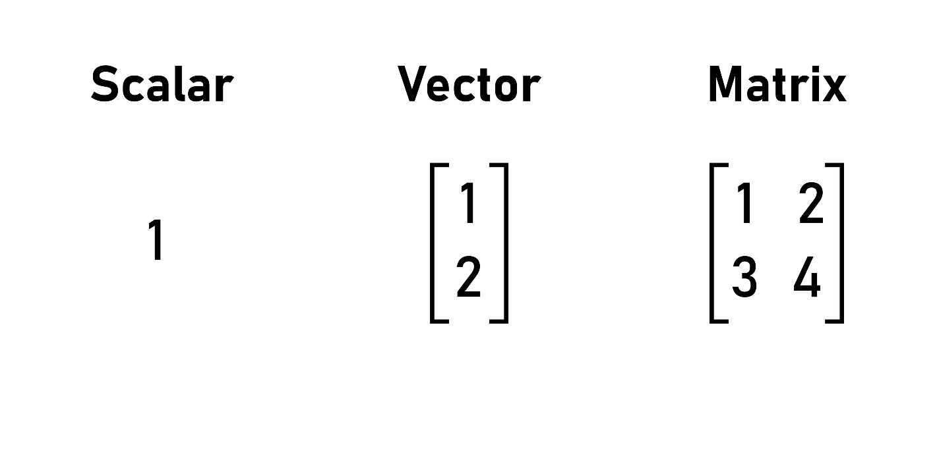
Shutterstock
Открыть

4. Statistical Distributions — "Baholar egri chizig‘i"
Maktabdagi sinfni eslang.
- 2-3 ta a'lochi bor (Kamchilik).
- 2-3 ta ikkichi bor (Kamchilik).
- Qolgan 20 ta o‘quvchi o‘rtacha "3" yoki "4" oladi (Ko‘pchilik).
- Mana shu shakl (o‘rtada do‘ppaygan, chetlari past) — Normal Taqsimot (Bell Curve) deyiladi. Statistika shuni o‘rganadi.
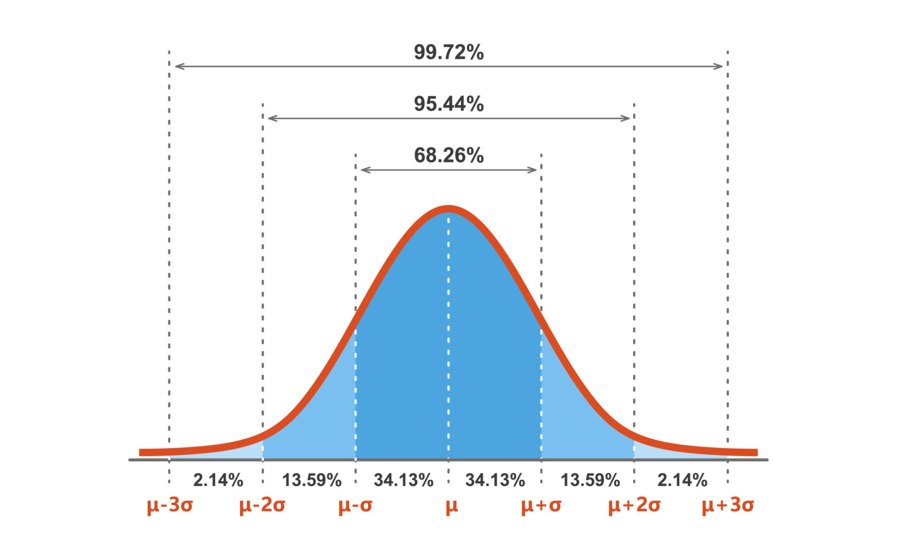
Getty Images

5. HPC Cluster — "Chumolilar kuchi"
Bitta kompyuter (chumoli) og‘ir yukni ko‘tara olmaydi.
- Agar 100 ta kompyuterni bir-biriga ulasangiz (TCP/IP tarmog‘i orqali), ular birlashib ulkan HPC Klasterga aylanadi va eng og‘ir masalani ham yecha oladi.
Xulosa:
Bu atamalar sizning "Data Science lug‘at boyligingiz"ni oshiradi. Endi siz shunchaki "kompyuter" demaysiz, balki "HPC Cluster" yoki "Matritsa" deb gapirib, professional ko‘rinasiz!
Keyingi bo‘limga o‘tishga tayyormisiz?

Ma'lumotlar bo'yicha sayohatingiz uchun yo'l xaritasi

Holati: Ingliz tilidan avtomatik tarjima qilindi

Ingliz tilidan avtomatik tarjima qilindi
Maʼlumot:
Bu elementda hali sevimli tilingizga tarjima qilinmagan kontent mavjud.
Ushbu infografikani qulay formatda ko'rish uchun shu yerni bo sing.
